
FACULTY OF COMPUTER SCIENCE AND IT
Bachelor’s in Software Engineering
DIPLOMA THESIS
Intelligent Credit Risk Decision System Using Machine Learning Techniques

FACULTY DEAN Prof. Asoc. Dr. Ligor NIKOLLA
HEAD OF DEPARTAMENT Dr. Elton DOMNORI
ACADEMIC ADVISOR PhD (c). Evis PLAKU
BACHELOR’S CANDIDATE Inviona HOXHA
Tirana, 2026

ABSTRACT
The Albanian banking sector currently relies on predominantly manual underwriting processes that are slow, inconsistent, and ill-equipped for the volume and velocity of modern credit applications. This thesis presents the design, development, and evaluation of Credit Risk Intelligent Predictor, an end-to-end intelligent credit risk assessment platform purpose-built for institutional deployment. The system integrates a high-performance machine learning engine which is centered on a tuned XGBoost classification model, with a modern full-stack web application consisting of a React/TypeScript frontend, a Python FastAPI backend, and a Supabase-managed database layer.
The predictive engine is trained on the Home Credit Default Risk dataset, comprising over 300,000 loan applications and 100+ features spanning demographic, financial, and bureau data. Rigorous preprocessing, feature engineering by including the construction of 30+ derived financial ratios, and hyperparameter optimization via grid search yield a final model achieving an AUC-ROC of 0.921, significantly outperforming logistic regression and random forest baselines. These results are consistent with findings from Lessmann et al. (2015), who demonstrated that gradient boosting methods consistently outperform logistic regression across diverse credit scoring benchmarks.
To address the interpretability requirements essential for regulatory compliance and ethical decision-making, the system integrates SHAP (SHapley Additive exPlanations) to generate per-prediction feature attribution. This approach aligns with the framework proposed by Hadji Misheva et al. (2021) in their comprehensive evaluation of explainable AI methods for credit risk management, which demonstrates that SHAP provides both theoretical grounding and practical intelligibility for adverse action notifications. Additionally, the ensemble explainability strategies documented by recent arXiv preprints (2025) combining XGBoost, LightGBM, and Random Forest with SHAP confirm the robustness of this approach across financial datasets. A configurable decision threshold framework allows institutions to tune the precision-recall trade-off in alignment with their specific risk appetite.
The platform supports both synchronous single-application assessment with sub-second latency and asynchronous batch processing capable of handling thousands of records via CSV upload. An embedded AI-powered financial assistant, leveraging Mistral’s language models, enables natural language interaction with portfolio data. The dashboard provides real-time KPI monitoring, interactive visualizations, and macro-economic context via live interest rate integration.

Keywords:
- Credit risk
- XGBoost
- SHAP
- Explainable AI
- Machine learning
- Ensemble models
- Albanian banking
- FastAPI
- React
- Loan default prediction
- FinTech
- Home Credit

ACKNOWLEDGEMENTS AND DEDICATIONS
I would like to express my deepest gratitude to my academic advisor, PhD (c). Evis Plaku, for consistent guidance, constructive feedback, and the intellectual rigor that shaped this thesis. The conversations we shared about system design, model interpretability, and the realities of Albanian banking were invaluable.
I am equally grateful to the Faculty of Computer Science and IT at the University Metropolitan Tirana for providing the academic environment and resources that made this research possible.
My sincere thanks also go to the open-source communities behind Python, scikit-learn, XGBoost, SHAP, FastAPI, React, and Supabase, the collective work of thousands of engineers that this project builds upon.
Finally, to my family and friends: your patience and encouragement throughout this demanding journey mean more than I can express.

DECLARATION OF AUTHENTICITY

I, Inviona Hoxha, understand that my thesis will become part of the collection of Metropolitan Tirana University. I hereby declare that the work presented in this thesis is my own original work. Any literature, studies, or work done by others and used in this thesis has been duly acknowledged and listed in the references section.

Date: ___/ ___/____ Signature: _________________________

Table of contents
Chapter 1: Introduction
$1.1$ Background of the Study
$1.2$ Problem Statement
$1.3$ Research Aim, Objectives, and Questions
$1.4$ Scope and Significance of the Study
$1.5$ Organization of the Thesis
Chapter 2: Literature Review
$2.1$ Credit Risk Assessment in Financial Institutions
$2.2$ Decision Support Systems for Credit Risk Management
$2.3$ Machine Learning Techniques for Credit Risk Prediction
$2.4$ Web-Based Analytical Dashboards and Intelligent Business Applications
$2.5$ Chatbots in Enterprise Decision Support and Related Work
Chapter 3: Research Methodology and System Design
$3.1$ Research Design and System Development Approach, Overall System Architecture, Integration, and Evaluation Procedure
$3.2$ Dataset Description and Data Acquisition
$3.3$ Data Preprocessing, Feature Engineering, and Exploratory Data Analysis
$3.4$ Development, Training, and Evaluation of Machine Learning Models
$3.5$ Design of the Web-Based Dashboard and Information Module
$3.6$ Design of the Chatbot Assistance Module
Chapter 4: System Implementation and Results
$4.1$ Development Tools, Technologies, and Implementation Environment
$4.2$ Implementation of the Credit Risk Prediction Module
$4.3$ Implementation of the Web-Based Dashboard and Information Features
$4.4$ Implementation of the Chatbot and System Integration
$4.5$ Experimental Results, System Testing, and Discussion
Chapter 5: Conclusions and Recommendations
$5.1$ Overview of the Study
$5.2$ Summary of Main Findings
$5.3$ Contributions of the Proposed System
$5.4$ Limitations of the Study
$5.5$ Recommendations for Future Work

Chapter 1: Introduction

The increasing availability of data and advancements in machine learning technologies have transformed the way financial institutions approach credit risk assessment. Traditional lending decisions, which have historically relied on manual evaluation and statistical scoring methods, are increasingly being complemented by intelligent systems capable of analyzing large volumes of borrower information and generating data-driven predictions. At the same time, growing regulatory expectations have emphasized the need for transparency, explainability, and accountability in automated decision-making processes.
Against this background, this thesis investigates the development of an intelligent credit risk assessment platform that combines machine learning, explainable artificial intelligence, and modern web technologies within a unified decision-support environment. The chapter introduces the research context, defines the problem addressed by the study, presents the research objectives and questions, outlines the scope and significance of the work, and concludes with an overview of the thesis structure.

1.1 Background of the Study

Credit risk sits at the center of every lending decision made by a financial institution. It represents the probability that a borrower will fail to meet contractual repayment obligations through delayed payment, partial default, or complete non-payment. Although the concept is straightforward, its management remains one of the most challenging aspects of financial operations. The quality of credit decisions directly affects the performance of a bank's loan portfolio, capital adequacy, long-term profitability, and overall financial stability. Consequently, credit risk assessment has remained a central topic in banking, finance, and risk management research for decades and continues to attract significant attention within the field of computational finance.
The transition from subjective human judgment to quantitative credit assessment methods began during the second half of the twentieth century. One of the earliest formalized credit scoring frameworks demonstrated that financial ratios could be combined into a mathematical model capable of predicting corporate financial distress with meaningful accuracy [1]. Subsequent developments introduced logistic regression as a practical tool for estimating default probabilities, providing outputs that were easier to interpret, calibrate, and justify within regulatory environments. Due to its balance between predictive performance and interpretability, logistic regression became the dominant approach in retail credit scoring for many years.
Advances in machine learning significantly transformed credit risk assessment methodologies. Ensemble learning techniques, particularly gradient boosting algorithms, consistently demonstrated superior predictive performance compared with traditional statistical approaches. Among these methods, XGBoost emerged as one of the most widely adopted algorithms due to its strong predictive accuracy, computational efficiency, and built-in regularization mechanisms [2]. A large-scale comparative study covering forty-one credit datasets and forty-one algorithm variants found that gradient boosting techniques significantly outperformed logistic regression on AUC-ROC, which remains one of the primary performance metrics in credit scoring applications [3]. More recent benchmarking studies further confirmed the superiority of gradient boosting approaches across multiple datasets and model families, particularly in environments characterized by class imbalance, a common characteristic of real-world credit default data [4].
Despite the significant progress achieved in predictive modeling, the adoption of advanced machine learning techniques within credit underwriting remains uneven. Large financial institutions in North America and Western Europe have invested heavily in automated risk assessment systems and have integrated predictive analytics into their operational workflows. In many emerging markets, however, credit evaluation continues to rely heavily on manual assessment procedures, rule-based decision frameworks, and traditional scoring approaches. Research has shown that weaknesses in risk management practices are associated with higher levels of non-performing loans (NPLs), even after controlling for broader macroeconomic factors [5]. These findings highlight the importance of modernizing credit assessment processes through the adoption of more robust analytical methods.
Albania represents a particularly relevant case within this context. The country's banking sector has undergone substantial regulatory and structural reforms over the past three decades, resulting in increased financial stability and closer alignment with European banking standards. Nevertheless, many lending processes continue to depend on document-based evaluations, committee reviews, and internally developed scoring practices that may lack consistency, scalability, and predictive sophistication. Although non-performing loan ratios have declined considerably compared with previous decades, they remain higher than those observed in many European Union member states, indicating continued opportunities for improvement in credit risk management practices.
Several technological developments have created favorable conditions for addressing this challenge. First, the availability of large-scale public credit datasets provides valuable opportunities for developing and evaluating predictive models using realistic borrower information. Second, the maturity of open-source machine learning frameworks has significantly reduced the technical and financial barriers associated with building advanced analytical systems. Third, advances in Explainable Artificial Intelligence (XAI) have improved the transparency of machine learning models, allowing institutions to better understand, justify, and communicate automated credit decisions while satisfying regulatory expectations [6].
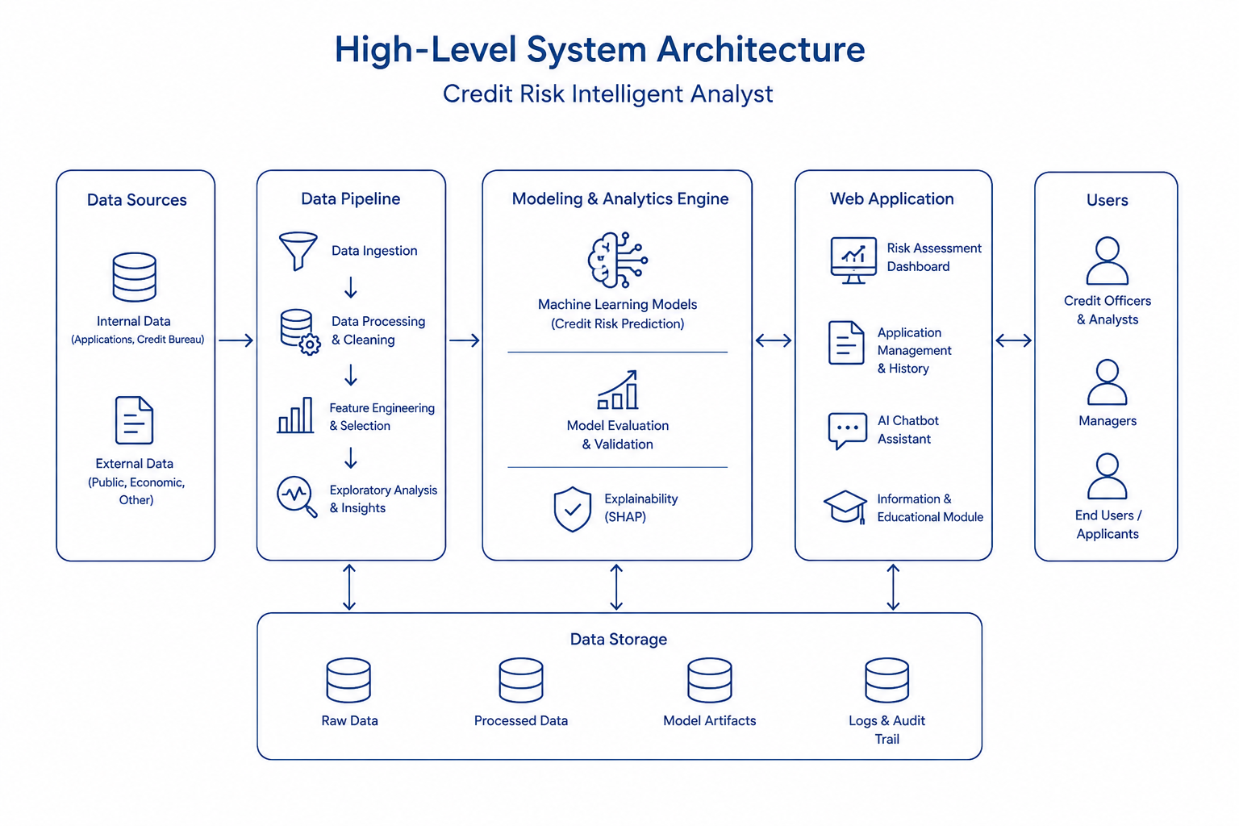
This research is motivated by the opportunity to combine these developments into an integrated solution that supports credit risk assessment within the Albanian banking context. The proposed system, named the Credit Risk Intelligent Predictor, extends beyond the development of a predictive model and focuses on delivering a complete decision-support platform. The system incorporates machine learning-based risk prediction, explainability mechanisms, interactive analytics, and conversational assistance within a unified environment designed to support institutional credit assessment workflows.
Figure 1 High-Level System Architecture - The proposed platform operates as an integrated workflow that systematically processes information from its raw state to a final, transparent decision. The architecture begins by aggregating internal bank records and external public data, which are subsequently cleaned and standardized through a dedicated data pipeline. This prepared data feeds directly into the modeling and analytics engine, which utilizes machine learning to predict credit default probabilities while employing explainability mechanisms to translate these complex models into clear, interpretable rationale. These insights are then delivered through a web application featuring intuitive dashboards, educational modules, and an interactive chatbot enabling credit officers and managers to make informed, data-driven lending decisions. Underpinning this entire pipeline is a secure data storage layer that systematically archives all raw inputs, processed metrics, and decision logs to ensure full accountability and regulatory compliance.

1.2 Problem Statement

The problem addressed by this thesis has both organizational and technological dimensions. From an organizational perspective, many financial institutions lack integrated, data-driven solutions capable of supporting credit risk assessment in a manner that is accurate, transparent, and operationally efficient. Existing approaches are often fragmented, relying on spreadsheet-based calculations, static decision rules, or proprietary software solutions that provide limited flexibility and customization. As a result, institutions may struggle to balance predictive accuracy, regulatory compliance, operational efficiency, and user accessibility within a single system.
From a technological perspective, a gap exists between advances in academic research and their practical implementation within banking environments. Numerous studies have demonstrated that modern machine learning techniques consistently outperform traditional statistical methods in credit risk prediction tasks [4]. However, adoption remains limited, particularly in emerging market contexts. One of the primary barriers is the difficulty of interpreting and explaining complex model decisions to stakeholders, including regulators, auditors, risk managers, and loan officers. Consequently, explainability has become a critical requirement for the successful deployment of machine learning systems in financial decision-making environments.
Recent research has demonstrated that SHAP-based explanations can provide transparent and consistent interpretations of individual credit decisions while supporting regulatory accountability requirements [6]. Additional studies have further confirmed the stability of SHAP feature attributions across different model architectures and datasets, reinforcing its suitability for financial applications [7]. These findings suggest that explainability techniques can help bridge the gap between predictive performance and institutional trust.
This thesis addresses these challenges through the development of an integrated platform that combines machine learning-based credit risk prediction, explainable AI, and a web-based decision-support environment. The objective is not only to achieve strong predictive performance but also to ensure that model outputs remain understandable, auditable, and practically useful within real-world credit assessment processes.

1.3 Research Aim, Objectives, and Research Questions

The primary aim of this research is to design, implement, and evaluate an intelligent credit risk assessment platform that integrates machine learning prediction, explainable artificial intelligence, and modern web technologies within a single decision-support system applicable to institutional banking environments.
To achieve this aim, the following research objectives are established:
- To develop and evaluate a machine learning pipeline capable of predicting loan default risk with high predictive performance using consumer credit data.
- To integrate explainable artificial intelligence techniques that provide transparent and interpretable explanations for individual model predictions.
- To design and implement a full-stack web-based platform that operationalizes machine learning predictions for institutional users.
- To support both real-time credit assessment and batch processing workflows commonly required in banking operations.
- To evaluate the practical applicability of AI-driven credit risk assessment within the context of Albanian financial institutions.
Based on these objectives, the study is guided by the following research questions:
RQ1: To what extent can machine learning models trained on publicly available consumer credit data achieve predictive performance suitable for credit risk assessment applications?
RQ2: How can explainable artificial intelligence techniques be integrated into a credit risk platform to provide transparent and interpretable decision support for institutional users?
RQ3: What system architecture and software engineering approaches are required to transform a machine learning model into a practical, deployable credit risk assessment platform?

1.4 Scope and Significance of the Study

The scope of this research is focused on the assessment of credit risk within the retail and consumer lending domain. The proposed system is designed to support the evaluation of individual loan applications by estimating the probability of borrower default using machine learning techniques. Corporate credit assessment, commercial lending, sovereign risk analysis, and other specialized credit evaluation domains are outside the scope of this study due to their distinct data requirements, risk characteristics, and modeling approaches.
The predictive component of the system is developed and evaluated using the Home Credit Default Risk dataset [8], a publicly available benchmark dataset widely used in credit scoring research. Although the dataset originates from a financial institution operating in emerging markets rather than Albania specifically, it provides a realistic environment for developing and evaluating credit risk models. The dataset contains demographic, financial, and behavioral attributes commonly used in consumer credit assessment and serves as a practical proxy for studying machine learning applications in emerging market lending contexts.
Within the proposed platform, the machine learning model functions as a decision-support mechanism rather than an autonomous decision-making system. Final lending decisions remain the responsibility of authorized credit officers and institutional stakeholders. The role of the platform is to provide risk predictions, supporting explanations, and analytical insights that can assist decision-makers during the credit evaluation process.
The significance of this study extends across academic, technological, and practical dimensions. From an academic perspective, existing literature has extensively examined individual aspects of credit risk assessment, including predictive modeling techniques, explainable artificial intelligence methods, and software engineering frameworks. However, relatively limited attention has been given to the development of end-to-end systems that integrate these components into a single operational platform. This research contributes to the growing body of knowledge by combining machine learning, explainability, and full-stack system development within a unified solution.
From a technological perspective, the study demonstrates how modern machine learning frameworks, explainability techniques, and web technologies can be integrated to create a practical decision-support environment. The resulting system illustrates the feasibility of deploying advanced analytical capabilities through accessible and scalable software architecture.
From a practical perspective, the research addresses challenges commonly faced by financial institutions when evaluating increasing volumes of credit applications. Manual assessment procedures can be time-consuming, difficult to scale, and potentially inconsistent across evaluators. By providing automated risk predictions together with transparent explanations, the proposed platform has the potential to support more efficient and informed lending decisions while maintaining accountability and regulatory compliance.
Furthermore, the study provides a foundation for future research and development efforts related to AI-driven financial services in Albania. As financial institutions continue to pursue digital transformation initiatives, the integration of explainable machine learning systems may play an increasingly important role in enhancing risk management practices and improving operational effectiveness.

1.5 Organization of the Thesis

The remainder of this thesis is organized into four chapters.
Chapter 2 presents the literature review and theoretical foundation of the study. It examines the evolution of credit risk assessment methodologies, machine learning applications in credit scoring, explainable artificial intelligence techniques, and the technological frameworks commonly used in intelligent decision-support systems. The chapter concludes by identifying research gaps and establishing the rationale for the proposed solution.
Chapter 3 describes the research methodology and system design. It outlines the overall research approach, dataset characteristics, data preprocessing procedures, feature engineering pipeline, machine learning model development process, evaluation methodology, and the architectural design of the proposed platform, including the dashboard and chatbot components.
Chapter 4 presents the implementation and evaluation of the system. This chapter details the development of the machine learning pipeline, the web-based platform, and the chatbot module. It also reports the experimental results, model performance metrics, explainability outcomes, and system-level evaluation findings.
Chapter 5 concludes the thesis by summarizing the research objectives, methodology, and key findings. The chapter discusses the contributions of the study, acknowledges its limitations, and provides recommendations for future research and potential system enhancements.

Chapter 2: Literature Review

The increasing adoption of machine learning technologies within financial services has transformed the way credit risk is assessed, monitored, and managed. Advances in predictive analytics have enabled financial institutions to move beyond traditional statistical scoring models toward more sophisticated approaches capable of capturing complex patterns within borrower data. At the same time, the growing use of complex machine learning models has introduced new challenges related to interpretability, transparency, regulatory compliance, and operational deployment. As a result, contemporary credit risk systems must balance predictive performance with explainability and practical usability.
This chapter critically reviews the academic and technical literature relevant to the development of intelligent credit risk assessment systems. The review examines the evolution of credit scoring methodologies, beginning with traditional statistical approaches and progressing toward modern machine learning techniques. Particular attention is given to the emergence of ensemble learning methods, which have become the dominant paradigm in contemporary credit risk prediction.
The chapter further investigates the role of decision support systems and explainable artificial intelligence within financial institutions, emphasizing the growing importance of transparent and accountable machine learning models in regulated environments. Existing research on SHAP-based explainability is examined to establish the theoretical and empirical foundations for interpretable credit risk assessment. In addition, the chapter reviews studies related to credit risk management in emerging markets, benchmark datasets commonly used in credit scoring research, and modern software architectures for deploying machine learning systems. Literature concerning analytical dashboards, conversational AI, and retrieval-augmented generation is also examined due to their relevance to the development of intelligent financial decision-support platforms.
The chapter concludes by identifying limitations within existing research and highlighting the gap addressed by this thesis. While substantial progress has been made in predictive modeling, explainability, and financial software engineering independently, relatively limited attention has been given to the development of integrated systems that combine these capabilities within a single operational platform. This gap provides the foundation for the research presented in this study.

2.1 Credit Risk Assessment in Financial Institutions

Credit risk assessment is a fundamental activity within financial institutions, as lending operations inherently involve uncertainty regarding a borrower's ability and willingness to meet future repayment obligations. Effective credit risk management enables banks to maintain portfolio quality, reduce default losses, comply with regulatory requirements, and support long-term financial stability. Consequently, the development of reliable credit assessment methodologies has been a central topic in banking research for several decades.
The evolution of credit risk assessment reflects a broader transition from subjective judgment-based decision making toward data-driven analytical approaches. Early lending decisions were largely dependent on the experience and intuition of loan officers, resulting in inconsistent evaluations and significant variability across institutions. As financial markets expanded and loan portfolios increased in complexity, the limitations of purely judgmental assessment became increasingly evident. This created the need for standardized and reproducible methods capable of supporting more objective credit decisions.

2.1.1 Evolution of Credit Scoring Models

One of the earliest quantitative approaches to credit risk assessment was introduced through Altman's Z-Score model, which applied linear discriminant analysis to financial statement ratios in order to predict corporate bankruptcy [1]. The significance of this work lies in its demonstration that financial distress could be estimated using measurable financial indicators rather than relying exclusively on expert judgment. The study established an important foundation for future credit scoring research by introducing the principle that borrower risk could be modeled statistically.
Despite its historical importance, the Z-Score model was developed primarily for corporate bankruptcy prediction and relied on assumptions such as linear separability and multivariate normality that are often violated in real-world credit data. As a result, its applicability to modern consumer lending environments is limited. Nevertheless, the model remains significant because it marked the beginning of quantitative credit risk assessment and influenced the development of subsequent scoring methodologies.
The introduction of logistic regression represented a major advancement in credit scoring research. Unlike discriminant analysis, logistic regression directly estimates the probability of a binary outcome and requires fewer restrictive statistical assumptions [9]. Its ability to produce interpretable probability estimates contributed significantly to its widespread adoption within financial institutions. For several decades, logistic regression remained the dominant methodology in retail credit scoring due to its balance between predictive performance, transparency, and regulatory acceptance.
A key advantage of logistic regression is its interpretability. The relationship between predictor variables and default probability can be examined directly through model coefficients, enabling analysts and regulators to understand how individual factors influence lending decisions. This transparency has made logistic regression particularly attractive in highly regulated environments where institutions must justify and document their decision-making processes.
However, the increasing availability of large datasets and advances in computational resources exposed important limitations of traditional statistical models. Consumer credit behavior is influenced by complex non-linear relationships and interactions between variables that cannot always be captured effectively through linear modeling approaches. As a result, researchers began exploring more advanced machine learning techniques capable of modeling these complexities.

2.1.2 Machine Learning in Credit Risk Prediction

The emergence of machine learning introduced a new paradigm for credit risk assessment. Rather than relying on predefined statistical relationships, machine learning algorithms learn patterns directly from historical data, allowing them to capture complex interactions among borrower characteristics, financial behavior, and repayment outcomes.
Among the earliest successful machine learning approaches applied to credit scoring were decision trees, neural networks, and support vector machines. Although these methods frequently demonstrated improved predictive performance compared to traditional statistical techniques, their adoption within banking environments remained limited. Concerns regarding model transparency, interpretability, and implementation complexity often outweighed the benefits of marginal performance improvements.
The most significant breakthrough occurred with the development of ensemble learning methods. Random Forests introduced the concept of combining multiple decision trees to improve prediction stability and reduce overfitting [10]. Building upon this concept, Gradient Boosting Machines further improved performance by sequentially correcting the errors of previously generated models [11]. These approaches demonstrated exceptional effectiveness on structured tabular datasets, which are common within financial applications.
The introduction of XGBoost represented a major milestone in applied machine learning for credit risk assessment [2]. Through optimized gradient boosting, regularization mechanisms, efficient handling of missing values, and scalable computation, XGBoost achieved state-of-the-art performance across numerous predictive modeling tasks. Consequently, it has become one of the most widely adopted algorithms in credit scoring research and industrial applications.
Several large-scale benchmarking studies provide strong empirical evidence supporting the superiority of gradient boosting methods. Lessmann et al. compared forty-one classification algorithms across multiple credit datasets and found that ensemble-based approaches consistently outperformed traditional statistical methods, including logistic regression [3]. Similarly, more recent benchmarking studies confirmed that XGBoost and related algorithms frequently achieve superior predictive performance across diverse credit risk datasets [4].
While these findings establish the effectiveness of machine learning models, much of the existing literature focuses primarily on predictive accuracy. Relatively limited attention has been given to challenges associated with explainability, system integration, and operational deployment. As a result, a gap remains between the development of high-performing predictive models and their practical adoption within institutional lending environments. This gap motivates the approach adopted in this thesis, which combines predictive performance with explainability and deployment considerations within a unified platform.

2.1.3 The Role of Feature Engineering in Credit Scoring

Although algorithm selection receives significant attention within the credit scoring literature, numerous studies suggest that feature engineering often has an equally important, if not greater, influence on predictive performance [12]. Feature engineering refers to the process of transforming raw variables into more informative representations that better capture underlying risk characteristics.
In credit risk assessment, engineered features frequently incorporate domain knowledge regarding borrower affordability, indebtedness, financial stability, and repayment behavior. Examples include debt-to-income ratios, credit utilization indicators, employment stability measures, and composite risk scores derived from multiple variables. Such features often provide stronger predictive signals than individual raw attributes.
Research has demonstrated that carefully designed financial ratios and derived indicators can significantly improve model performance across various machine learning algorithms [12]. Furthermore, benchmarking studies have shown that gains achieved through feature engineering may exceed those obtained solely through hyperparameter optimization [4]. These findings highlight the importance of combining advanced machine learning techniques with domain expertise rather than relying exclusively on algorithmic complexity.
Despite this evidence, many credit scoring studies focus primarily on model comparison while providing limited discussion of feature construction methodologies. This reduces reproducibility and makes it difficult to assess the contribution of engineered variables to overall performance. To address this limitation, the present research explicitly documents the feature engineering process and the financial indicators derived from the Home Credit dataset. This approach improves transparency and facilitates future replication and validation of the proposed methodology.

2.2 Decision Support Systems for Credit Risk Management

Decision Support Systems (DSS) are information systems designed to assist decision-makers by providing analytical capabilities, structured information, and data-driven insights. Unlike fully automated systems, DSS solutions are intended to support rather than replace human judgment, making them particularly suitable for financial environments where accountability and regulatory compliance remain essential requirements [13].
Within credit risk management, decision support systems have evolved considerably over the past decades. Early implementations primarily focused on collecting borrower information and generating standardized reports for credit committees. As analytical techniques matured, statistical credit scoring models were integrated into these systems, enabling institutions to supplement expert judgment with quantitative risk assessments.
Recent advances in machine learning have expanded the capabilities of modern DSS platforms beyond simple risk scoring. Contemporary systems increasingly incorporate predictive analytics, interactive visualizations, real-time monitoring, and automated reporting functionalities. These developments allow credit officers to evaluate borrower risk more efficiently while maintaining oversight over the final decision-making process.
Research consistently indicates that data-driven decision support systems can improve decision consistency, reduce processing time, and enhance risk management outcomes when compared to purely judgment-based approaches [14]. However, many existing studies focus primarily on predictive performance and provide limited discussion regarding system usability, explainability, and integration within operational workflows.
This limitation is particularly relevant in banking environments, where successful adoption depends not only on model accuracy but also on the ability of users to understand, trust, and effectively utilize system outputs. Consequently, modern credit risk platforms must combine analytical capabilities with intuitive interfaces and transparent explanations. This perspective directly informs the design of the system proposed in this thesis, which integrates predictive modeling, explainability, analytical dashboards, and conversational assistance within a unified decision-support environment.

2.3 Explainable Artificial Intelligence in Credit Risk Assessment

As machine learning models become increasingly sophisticated, concerns regarding transparency and interpretability have become more prominent, particularly in highly regulated sectors such as banking and finance. While advanced algorithms often achieve superior predictive performance, their complexity can make decision-making processes difficult to understand and justify. This challenge has led to the emergence of Explainable Artificial Intelligence (XAI), a field focused on making machine learning predictions more transparent and understandable. The following sections examine the importance of explainability in financial services, discuss SHAP as a widely adopted interpretation framework, and review empirical studies that demonstrate its effectiveness in credit risk assessment applications.

2.3.1 The Need for Explainability in Financial Services

The adoption of machine learning models in financial decision-making has significantly improved predictive performance in areas such as fraud detection, customer segmentation, and credit risk assessment. However, the increasing complexity of these models has introduced concerns regarding transparency and accountability. Unlike traditional statistical models, many machine learning algorithms operate as "black boxes," making it difficult for stakeholders to understand how predictions are generated.
This challenge is particularly important within the banking sector, where lending decisions directly affect individuals and organizations. Regulatory frameworks increasingly require institutions to justify adverse credit decisions and demonstrate that automated systems operate in a fair and transparent manner. Consequently, predictive accuracy alone is insufficient for practical deployment. Financial institutions must also be able to explain why a specific borrower was classified as high or low risk.
Explainable Artificial Intelligence (XAI) emerged as a response to this challenge. The objective of XAI is to provide understandable explanations for machine learning predictions without significantly reducing predictive performance. By improving transparency, explainability enhances stakeholder trust, supports regulatory compliance, and facilitates model validation and auditing.

2.3.2 SHAP as a Framework for Model Interpretation

Among the various explainability techniques proposed in recent years, SHAP (SHapley Additive exPlanations) has become one of the most widely adopted approaches for interpreting machine learning models [17]. SHAP is based on concepts derived from cooperative game theory and estimates the contribution of each feature to a model's prediction.
One of the primary advantages of SHAP is that it provides both global and local interpretability. Global explanations allow analysts to understand which variables influence model behavior across the entire dataset, while local explanations reveal the factors that contribute to individual predictions. This dual perspective is particularly valuable in credit risk assessment, where institutions must understand both portfolio-level trends and borrower-specific outcomes.
Compared with alternative explainability approaches discussed in the literature, SHAP offers strong theoretical guarantees regarding consistency and feature attribution. For tree-based models such as XGBoost, the TreeSHAP algorithm enables efficient computation of explanations, making it suitable for real-time decision-support systems. These characteristics have contributed to its widespread adoption in financial machine learning applications.

2.3.3 Empirical Evidence for SHAP in Credit Risk Applications

Recent studies have demonstrated the effectiveness of SHAP in explaining credit risk predictions generated by machine learning models. Research by Hadji Misheva et al. [6] found that SHAP provides stable and reproducible explanations while maintaining consistency across repeated evaluations. The study concluded that SHAP explanations can support transparency requirements in credit risk management and facilitate communication between technical and non-technical stakeholders.
Additional research has confirmed the usefulness of SHAP for identifying the most influential factors driving default predictions across different financial datasets [7]. Commonly identified variables include borrower income, debt-related indicators, employment stability measures, and historical repayment behavior. These findings suggest that SHAP can not only explain individual decisions but also provide valuable insights into broader risk patterns.
Despite the growing body of research validating SHAP as an explainability framework, most studies focus primarily on model interpretation rather than system integration. Limited attention has been given to how explanations should be presented within operational decision-support platforms or how non-technical users interact with explanation outputs during credit assessment workflows. This represents an important gap within the literature.
To address this limitation, the present research incorporates SHAP explanations directly into a web-based credit risk assessment platform. Rather than treating explainability as a separate analytical process, SHAP is integrated as a core system feature that supports both individual credit evaluation and portfolio-level analysis.

2.4 Credit Risk Management in Emerging Markets

Credit risk management practices vary significantly across countries and financial systems due to differences in economic development, regulatory frameworks, data availability, and institutional maturity. While large financial institutions in developed markets have increasingly adopted data-driven credit assessment systems, many emerging economies continue to rely on a combination of traditional underwriting procedures and manual decision-making processes.
Research examining banking performance in emerging markets suggests that the quality of credit risk management is strongly associated with loan portfolio performance and financial stability [5]. Institutions that employ structured, data-driven assessment frameworks generally demonstrate lower levels of non-performing loans and greater consistency in lending decisions compared to institutions that rely primarily on subjective evaluation processes. These findings highlight the potential value of analytical decision-support tools within developing banking environments.
However, much of the existing literature focuses on large financial markets such as the United States, Western Europe, China, and India. Comparatively limited research has examined the adoption of machine learning and explainable artificial intelligence within smaller emerging economies. As a result, there remains a gap in understanding how advanced credit risk assessment technologies can be adapted and applied within these contexts.
The Albanian banking sector presents an interesting example of this challenge. Over recent decades, the sector has undergone significant regulatory and structural reforms aimed at improving financial stability and aligning domestic practices with European standards. Nevertheless, publicly available research concerning the use of machine learning and explainable AI for credit risk assessment within Albanian financial institutions remains limited. This lack of evidence makes it difficult to evaluate the practical applicability of advanced credit scoring systems in the local context.
A further consideration relates to data availability. Due to the absence of publicly accessible Albanian credit risk datasets, researchers frequently rely on international benchmark datasets when developing and evaluating predictive models. While this approach enables methodological validation, it also introduces limitations regarding external validity. Borrower behavior, economic conditions, lending policies, and regulatory requirements may differ significantly between countries, meaning that results obtained using international datasets cannot be assumed to transfer directly to Albanian financial institutions.
Consequently, the contribution of this research should be interpreted primarily as a demonstration of methodological and technological feasibility rather than a direct representation of credit risk behavior within Albania. The proposed system provides evidence that machine learning, explainable artificial intelligence, and modern decision-support technologies can be integrated into a unified platform suitable for credit risk assessment. Future studies utilizing institution-specific Albanian data would be required to evaluate real-world predictive performance and operational impact.

2.5 Benchmark Datasets and Credit Risk Modeling

The development of reliable credit risk prediction models depends not only on the selection of appropriate machine learning algorithms but also on the quality of the data used for training and evaluation. Over the past decade, publicly available benchmark datasets have played a significant role in advancing credit scoring research by enabling the comparison of different modeling approaches under consistent conditions. At the same time, challenges such as class imbalance, missing values, and threshold selection continue to influence model performance and practical applicability. This section reviews the Home Credit Default Risk dataset, one of the most widely used benchmarks in credit risk research, and discusses key methodological considerations that affect the development and evaluation of predictive models.

2.5.1 The Home Credit Default Risk Dataset

The availability of high-quality datasets plays a critical role in the development and evaluation of credit risk models. Among the publicly available datasets used in credit scoring research, the Home Credit Default Risk dataset has emerged as one of the most widely adopted benchmarks [8]. Released through a Kaggle competition in 2018, the dataset contains information from more than 300,000 consumer loan applications and includes demographic, financial, behavioral, and historical credit-related attributes.
The popularity of the Home Credit dataset can largely be attributed to its size, complexity, and resemblance to real-world lending environments. Unlike many academic benchmark datasets, it contains substantial missing values, multiple relational tables, and naturally imbalanced class distributions, making it more representative of practical credit risk modeling challenges. Consequently, numerous studies have used the dataset to evaluate machine learning algorithms, feature engineering techniques, and explainability frameworks.
Despite these advantages, the dataset also presents important limitations. The data originates from a specific lending institution operating within particular emerging market environments and therefore reflects the characteristics, lending policies, and customer behaviors associated with that context. As a result, findings derived from the dataset cannot be assumed to generalize directly to other countries or financial systems. For this reason, the dataset is used in this research primarily as a benchmark for methodological evaluation rather than as a direct representation of Albanian borrowers.

2.5.2 Class Imbalance and Threshold Selection

A common challenge in credit risk prediction is class imbalance, where the number of non-default observations significantly exceeds the number of default cases. This characteristic is typical of real-world lending data because most borrowers successfully repay their obligations. While such distributions reflect practical conditions, they create challenges for predictive modeling and performance evaluation.
In imbalanced datasets, traditional accuracy measures can produce misleading results. A model that predicts every borrower as non-default may achieve high accuracy while providing little practical value for risk assessment. Consequently, the literature recommends the use of evaluation metrics that better capture a model's ability to distinguish between default and non-default cases, particularly the Area Under the Receiver Operating Characteristic Curve (AUC-ROC) [15].
Another important consideration is threshold selection. Most machine learning models produce probabilities rather than direct classifications, requiring a decision threshold to determine whether an applicant should be classified as high or low risk. The optimal threshold depends on institutional objectives, risk tolerance, and regulatory considerations. A lower threshold may identify a larger proportion of risky borrowers but can increase false positives, whereas a higher threshold may reduce unnecessary rejections at the expense of increased default exposure.
Although many studies emphasize predictive performance, threshold calibration is often treated as a secondary consideration despite its direct impact on operational decision-making. This research recognizes threshold selection as an important component of credit risk assessment and incorporates threshold optimization within the overall evaluation framework described in Chapter 3.

2.6 Modern Software Architectures for Intelligent Financial Systems

The growing adoption of artificial intelligence and data-driven decision-making has transformed the way financial systems are designed and deployed. Modern intelligent applications are no longer limited to predictive models alone but increasingly integrate data visualization, scalable deployment architectures, and conversational interfaces to support user interaction and decision-making. As financial institutions seek to operationalize machine learning solutions, attention has shifted toward creating systems that are not only accurate but also accessible, maintainable, and capable of supporting real-world business processes. This section reviews key developments in web-based analytical dashboards, machine learning deployment architectures, and conversational AI technologies that underpin contemporary intelligent financial systems.

2.6.1 Web-Based Analytical Dashboards

The effectiveness of intelligent decision-support systems depends not only on predictive accuracy but also on how analytical results are presented to end users. Research in business intelligence and data visualization consistently demonstrates that interactive dashboards improve decision quality by enabling users to explore information, identify patterns, and monitor key performance indicators more efficiently than traditional static reports [21].
Within financial institutions, dashboards are increasingly used to support risk management, portfolio monitoring, and operational decision-making. Modern analytical platforms typically combine data visualization, performance metrics, and predictive analytics within a single interface, allowing users to access relevant information without requiring advanced technical expertise. This integration is particularly important in credit risk assessment, where decision-makers must evaluate both individual borrower characteristics and broader portfolio trends.
Despite advances in visualization technologies, much of the existing literature focuses on analytical performance rather than user interaction. As a result, relatively limited attention has been given to how machine learning outputs and explainability results should be presented to non-technical users. This limitation highlights the importance of designing interfaces that not only display predictions but also communicate the reasoning behind those predictions in an understandable manner.

2.6.2 Machine Learning Deployment and System Integration

The successful adoption of machine learning systems requires more than the development of accurate predictive models. Research in machine learning operations (MLOps) emphasizes that practical value is achieved only when models can be reliably deployed, monitored, and integrated within existing organizational workflows [18].
Recent studies have highlighted the importance of scalable web architectures that separate predictive services from presentation layers through application programming interfaces (APIs). This architectural approach improves maintainability, flexibility, and system scalability while enabling machine learning models to be accessed by multiple applications and user groups. Such architectures have become increasingly common within financial technology platforms due to their ability to support real-time decision-making and high-volume data processing requirements.
Although significant progress has been made in model deployment technologies, many academic studies remain focused on predictive performance and provide limited discussion regarding operational implementation. Consequently, a gap remains between machine learning research and production-ready financial systems. This research addresses that gap by integrating predictive analytics, explainability, and user interaction within a unified platform architecture.

2.6.3 Conversational Artificial Intelligence in Financial Services

Recent advances in large language models (LLMs) have expanded the capabilities of intelligent decision-support systems beyond traditional dashboards and reporting tools. Conversational AI enables users to interact with complex datasets using natural language, reducing the technical barriers associated with querying and interpreting information.
Financial institutions have increasingly explored the use of conversational assistants for customer support, information retrieval, and analytical assistance. Research suggests that natural language interfaces can improve accessibility by allowing users to obtain insights without requiring knowledge of database query languages or specialized analytical tools [22].
However, the use of general-purpose language models within financial environments introduces concerns regarding factual accuracy, reliability, and regulatory compliance. Models may generate responses that appear plausible but are not supported by underlying data, a phenomenon commonly referred to as hallucination. To address this challenge, recent research has focused on Retrieval-Augmented Generation (RAG), an architectural approach that combines language generation with information retrieval mechanisms [23].
Under the RAG paradigm, responses are generated using both the language model's capabilities and information retrieved from trusted data sources. This approach improves factual grounding and reduces the likelihood of unsupported responses. As a result, RAG has emerged as one of the most widely adopted strategies for integrating conversational AI into enterprise and financial applications.
The literature demonstrates the growing potential of conversational AI within decision-support environments. However, relatively few studies have examined the integration of machine learning prediction, explainability, analytical dashboards, and conversational assistance within a single financial platform. This limitation further supports the need for integrated systems that combine these capabilities to enhance credit risk assessment and decision-making processes.

2.7 Gap Analysis and Research Positioning

The literature reviewed in this chapter reveals several clear gaps that define the positioning of this thesis. First, although individual components of intelligent credit risk systems, such as gradient boosting models, SHAP-based explainability, web-based architectures, and large language model assistants, are well established, there is still a lack of end-to-end integrated systems that combine these elements within a single operational platform. Existing studies primarily focus on isolated model development or explanation techniques, with limited attention to system-level integration, deployment, and usability in real-world financial environments.
Second, research on advanced credit risk systems in emerging markets remains limited, particularly in smaller economies such as Albania. While evidence from larger financial systems demonstrates the benefits of data-driven credit assessment, these findings do not fully reflect the institutional and operational constraints of developing banking environments. Studies on emerging markets indicate that credit risk management practices significantly influence portfolio quality and non-performing loan levels [5], yet there is limited work translating these insights into practical, system-level implementations tailored to such contexts. This thesis addresses this gap by situating its contribution within the Albanian banking environment.
Third, although the Explainable AI (XAI) literature provides strong theoretical foundations for methods such as SHAP, most existing studies evaluate explainability at the model level rather than within integrated decision-support systems. Research such as Hadji Misheva et al. (2021) [6] and recent ensemble-based studies [7] focus on explanation quality and stability, but provide limited guidance on how explanations should be embedded into operational interfaces used by non-technical stakeholders such as credit officers. As a result, the system-level design and usability aspects of explainability remain underexplored.
Finally, existing work rarely treats explainability as part of the user experience layer in financial decision-support systems. Beyond generating accurate explanations, there is a need to ensure that these outputs are presented in a clear, interpretable, and operationally meaningful way that supports real-time decision-making workflows.
Taken together, these gaps define the contribution of this thesis. This research develops an end-to-end intelligent credit risk platform that integrates machine learning prediction, SHAP-based explainability, web-based decision support, and conversational AI within a unified system. The proposed solution is designed with a focus on usability and operational deployment and is contextualized for the Albanian banking environment, bridging the gap between predictive modeling research and production-ready financial systems.

Chapter 3: Research Methodology and System Design

This chapter presents the methodology and system design adopted for the development of the Credit Risk Intelligent Predictor. The chapter describes the research approach, overall system architecture, development process, technology selection rationale, and the integration of machine learning components within a web-based decision-support platform.
The proposed solution combines predictive analytics, explainable artificial intelligence, interactive dashboards, and conversational assistance within a unified system designed to support credit risk assessment. Particular attention is given to the engineering decisions that guided the implementation, the interaction between system components, and the mechanisms used to ensure scalability, maintainability, and usability.
The chapter also discusses the dataset used for model development, the preprocessing and feature engineering procedures applied to the data, and the evaluation methodology adopted for validating predictive performance. Finally, the design of the web dashboard and chatbot module is presented to demonstrate how machine learning outputs are delivered to end users in an accessible and interpretable manner.

3.1 Research Design and System Development Approach

This research follows a design science methodology, which is commonly applied in software engineering studies where the primary objective is the development of a functional artifact capable of addressing a practical problem. Rather than focusing solely on theoretical analysis, design science emphasizes the creation, implementation, and evaluation of a solution that can be applied in a real-world environment.

The artifact developed in this research is an intelligent credit risk assessment platform that combines machine learning prediction, explainable AI, analytical visualization, and conversational assistance within a single web-based system. The development process followed an iterative approach in which individual system components were progressively refined and integrated throughout the project lifecycle.

The overall development process consisted of four main phases:

- Data acquisition and preparation.
- Machine learning model development and evaluation.
- Backend and database implementation.
- Frontend dashboard and user interface development.

Each phase contributed incrementally to the final platform and allowed continuous testing and validation during implementation.
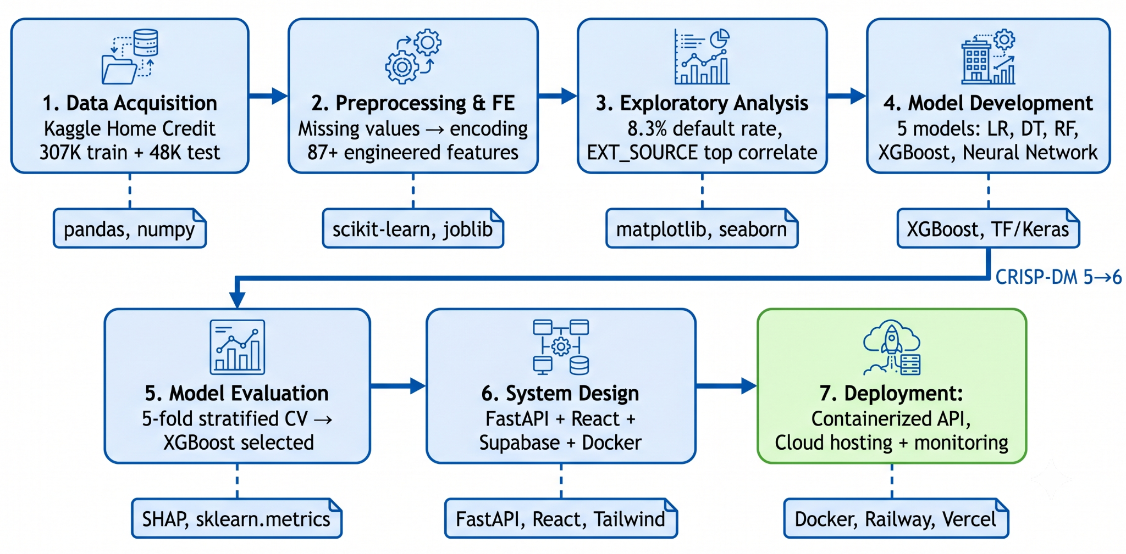
Figure 3.1 Research and Development Lifecycle - illustrates the overall development lifecycle followed in this research. The process begins with data acquisition and preprocessing, followed by machine learning model development, backend and database implementation, frontend development, and final system validation.

3.1.1 Research Design Strategy

The study adopts a design science research strategy because the primary objective is the creation of a software artifact rather than the investigation of a naturally occurring phenomenon. Design science is particularly suitable for software engineering projects where knowledge is generated through the design, implementation, and evaluation of a technological solution.
An iterative development approach inspired by agile principles was employed throughout the project. Instead of implementing the entire system in a single development cycle, the platform was constructed incrementally through multiple iterations. Early versions focused on establishing the machine learning pipeline and validating predictive performance, while later iterations concentrated on explainability features, dashboard functionality, and user interaction.
This approach provided several advantages. First, it allowed machine learning models to be tested independently before being integrated into the web platform. Second, it enabled continuous refinement of user interface components based on implementation feedback. Finally, it reduced development risk by identifying integration challenges early in the project lifecycle.
The resulting artifact was evaluated through both technical performance metrics and functional system testing. Machine learning evaluation focused on predictive performance, while system evaluation examined functionality, usability, and integration across all platform components.
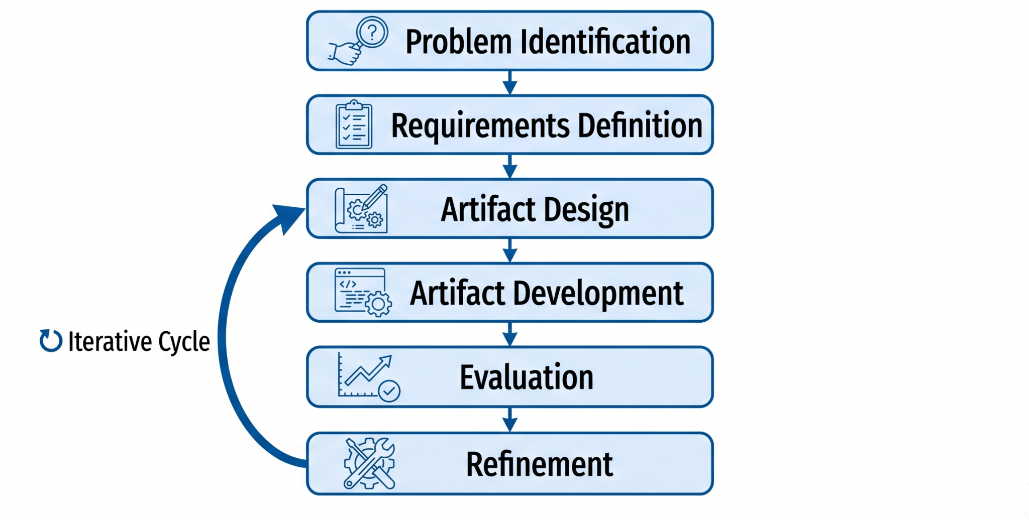
Figure 3.2 Design Science Research Process - presents the design science process adopted in this research. The artifact is developed iteratively through repeated cycles of design, implementation, evaluation, and refinement until the final solution satisfies the defined requirements.

To understand more about the project structure we may look at the table below.
Phase | Objective | Output
Phase 1 | Data acquisition and preparation | Processed dataset
Phase 2 | Model development and evaluation | Trained XGBoost model
Phase 3 | Backend and database implementation | Prediction API and database
Phase 4 | Frontend and dashboard development | Complete web application
Phase 5 | Testing and validation | Evaluated platform
Table 3.1 Research Phases and Objectives - This table shows all the phases that this project structure have passed through to achieve the current output.

3.1.2 Overall System Architecture
The Credit Risk Intelligent Predictor is structured as a modern three-tier web application comprising a presentation layer, an application logic layer, and a data layer. This architectural pattern was selected deliberately because it enforces a clean separation of concerns, improves maintainability and testability, and enables independent scaling of each tier as operational requirements evolve [25].
The presentation layer is implemented as a single-page application (SPA) built with React 18 and TypeScript. It is responsible for all user interaction, including the credit assessment form, the analytical dashboard, the batch processing interface, and the conversational assistant widget. The application communicates exclusively with the backend through well-defined API contracts, ensuring that no business logic or data persistence resides in the browser.
The application logic layer consists of two distinct services. The first is a Python FastAPI server that encapsulates the machine learning pipeline, executes credit risk predictions, computes SHAP attributions, and exposes these capabilities through RESTful endpoints. The second is a set of Supabase Edge Functions deployed at the network edge, which handle authentication-gated batch processing requests and mediate between the frontend and the Python prediction service.
The data layer is managed by Supabase, an open-source Backend-as-a-Service platform built on PostgreSQL. It stores user profiles, loan application records, prediction outputs, and audit trails. Row-Level Security (RLS) policies enforced at the database level ensure that each authenticated user can access only their own data, satisfying basic data isolation requirements without requiring additional application-level access control logic.

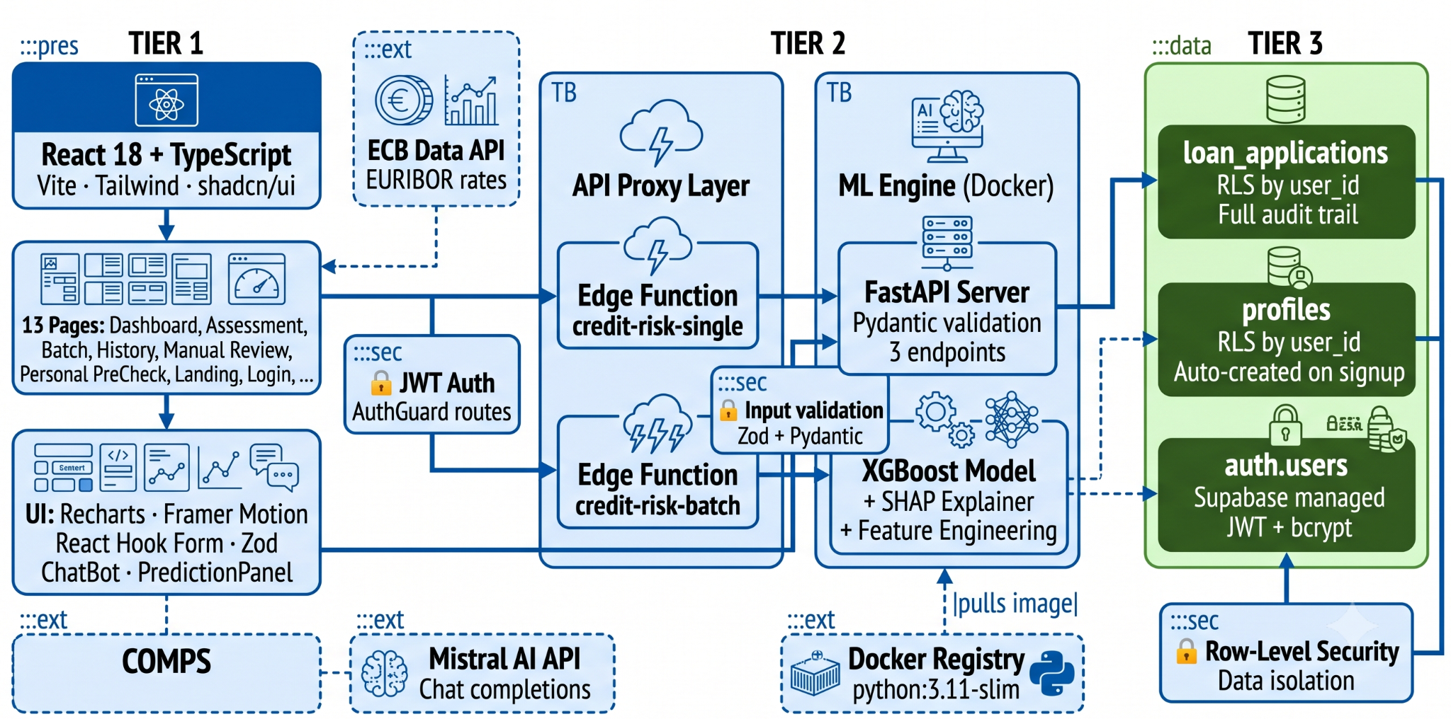
Figure 3.3 Three-Tier Architecture Diagram - illustrates the three-tier architecture of the proposed platform. The presentation layer manages user interaction, the application layer executes predictive and business logic, and the data layer handles storage and authentication services.

3.1.3 System Integration and Data Flow

The Credit Risk Intelligent Predictor integrates multiple software components that work together to provide real-time credit risk assessment, explainable predictions, historical record management, and user interaction. The system was designed using a service-oriented architecture in which each component performs a specific responsibility while communicating through clearly defined interfaces.
At a high level, the platform consists of four primary components: the React frontend application, Supabase services, the FastAPI prediction service, and the PostgreSQL database. Communication between these components is performed through REST-based API requests and structured JSON responses.
When a user submits a credit assessment request, the frontend collects the applicant information through the assessment form and transmits the data to the backend layer. The request is validated and forwarded to the prediction service, where preprocessing, feature engineering, model inference, and explainability generation are performed. The resulting prediction and explanation data are then returned to the frontend and simultaneously stored within the database for future retrieval and analysis.
This architecture ensures that predictive logic remains isolated from presentation logic while maintaining a clear separation between user interaction, business processing, and data persistence responsibilities.

3.1.3.1 Single Assessment Workflow

The single assessment workflow represents the primary operational scenario of the platform. In this process, a credit analyst enters applicant information through the assessment interface and initiates a prediction request.
After receiving the request, the backend validates the submitted data and forwards it to the FastAPI prediction service. The prediction service applies the same preprocessing and feature engineering pipeline used during model training, ensuring consistency between training and inference environments. The processed features are then passed to the trained XGBoost model, which generates a probability score representing the likelihood of default.
Following prediction, SHAP values are calculated to identify the factors contributing most significantly to the decision. Both the prediction result and explanation outputs are returned to the frontend and stored in the database. The dashboard subsequently presents the decision outcome, risk classification, probability score, and explanation visualizations to the user.
This workflow enables near real-time credit assessment while maintaining transparency through integrated explainability mechanisms.

3.1.3.2 Batch Assessment Workflow

In addition to individual assessments, the platform supports batch processing of multiple loan applications through CSV file uploads. This functionality is intended for institutional environments where large volumes of applications must be evaluated simultaneously.
When a CSV file is uploaded, the frontend transfers the file contents to a dedicated backend endpoint. The records are parsed and transformed into structured applicant objects before being forwarded to the prediction service. Each application is processed independently through the same preprocessing, feature engineering, prediction, and explainability pipeline used for single assessments.
After processing is complete, the prediction results are aggregated and returned to the user as a consolidated response. The results are also stored in the database, enabling future retrieval through the history module and dashboard analytics.
The use of a shared prediction pipeline for both single and batch assessments ensures consistency and prevents discrepancies between evaluation modes.

3.1.3.3 Database Interaction and Persistence

The PostgreSQL database managed through Supabase serves as the central repository for platform data. Assessment records, prediction outcomes, user information, and historical activity are persisted within the database to support analytical reporting and auditability.
Every completed assessment generates a new database record containing the applicant identifier, prediction result, risk level, probability score, timestamp, and associated user information. Historical records can subsequently be retrieved through dashboard queries and filtered according to user-defined criteria.
To ensure data security, Row-Level Security policies restrict access to records belonging to authenticated users. This approach enforces data isolation at the database layer and reduces reliance on application-level security controls.
The persistence of prediction results enables the platform to function not only as a prediction tool but also as a historical decision-support system capable of supporting future analysis and reporting activities.

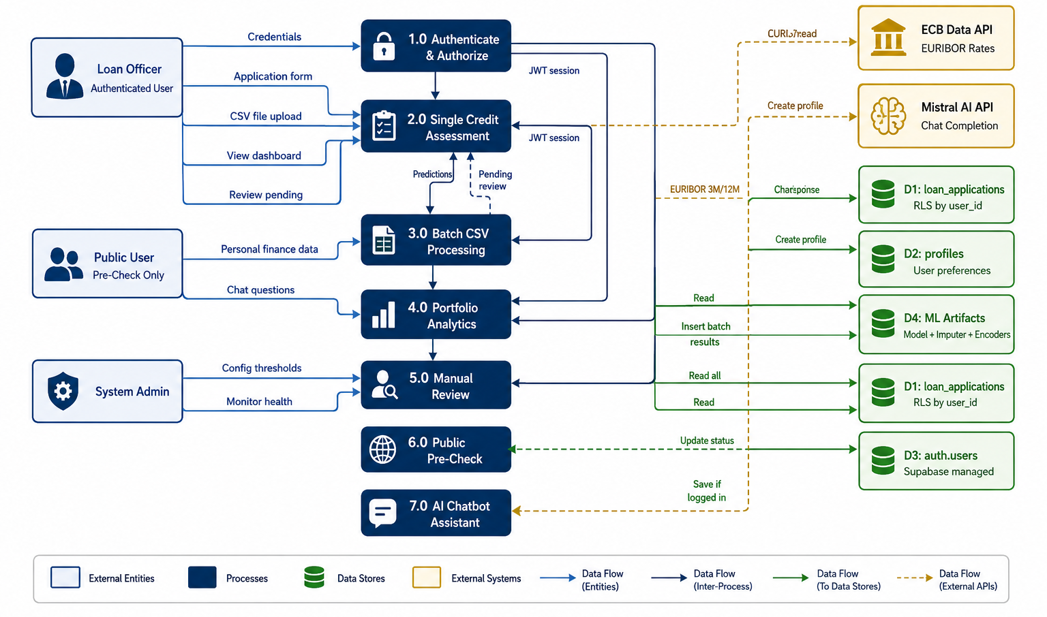
Figure 3.4 System Integration and Data Flow Diagram - illustrates the interaction between the major components of the Credit Risk Intelligent Predictor. User requests originate from the frontend application, pass through backend services for prediction and explainability generation, and are subsequently stored within the database for visualization and historical analysis.

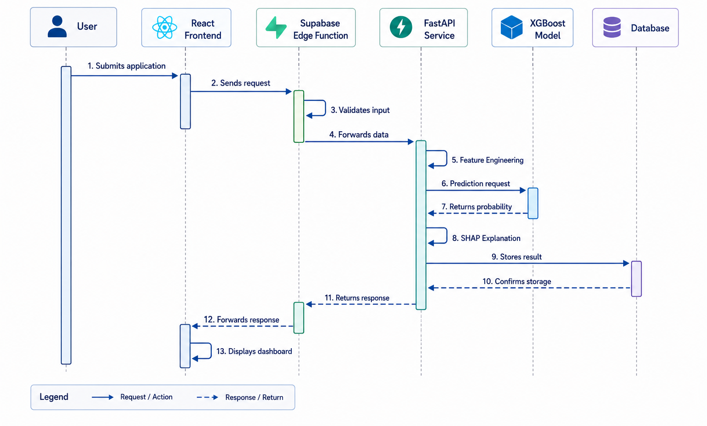
Figure 3.3 Single Assessment Sequence Diagram - presents the sequence of interactions executed during a single credit assessment request. The workflow demonstrates how user input is transformed into a prediction result and subsequently persisted within the platform.

3.1.4 Technology Selection Rationale
The technologies used in the Credit Risk Intelligent Predictor were selected based on four primary criteria: compatibility with machine learning workflows, development efficiency, scalability, and suitability for financial decision-support applications. The selected technology stack enables the integration of predictive analytics, explainable artificial intelligence, web-based visualization, and conversational assistance within a unified platform architecture.

3.1.4.1 Frontend Technologies
The frontend layer was developed using React and TypeScript. React was selected because its component-based architecture supports the development of modular and reusable user interface elements, making it well suited for dashboard-oriented applications. TypeScript was used to introduce static type checking, improving code reliability and reducing runtime errors during communication with backend services.

The frontend is responsible for collecting applicant information, displaying prediction results, presenting SHAP-based explanations, and providing access to historical assessment records and analytical dashboards. Additional libraries were incorporated for routing, form validation, state management, and data visualization, enabling the development of a responsive and interactive user experience.

3.1.4.2 Backend Technologies

The backend was implemented using Python and FastAPI. Python was selected due to its extensive ecosystem for data science and machine learning, including libraries such as XGBoost, Scikit-learn, Pandas, and SHAP.
FastAPI was chosen as the API framework because it provides high performance, automatic request validation, and straightforward integration with machine learning services. The backend encapsulates the complete prediction workflow, including preprocessing, feature engineering, model inference, and explainability generation. Exposing these capabilities through RESTful APIs enables the frontend and other services to access prediction functionality through a standardized interface.

3.1.4.3 Data Management Technologies

Data storage and user authentication are managed through Supabase, which provides a PostgreSQL-based backend platform. Supabase was selected because it combines database management, authentication services, serverless functions, and security mechanisms within a single environment.
The platform stores user accounts, loan application records, prediction results, and assessment history. Row-Level Security (RLS) policies are used to ensure that users can access only their own records, supporting data isolation and basic security requirements. Supabase Edge Functions also act as an intermediary layer between the frontend and prediction service, simplifying request handling and batch-processing operations.

3.1.4.4 Machine Learning Technologies

The predictive component of the system is based on the XGBoost classification algorithm. The selection of XGBoost was motivated by its strong performance on structured tabular datasets and its widespread adoption within credit risk modeling research.
The model receives preprocessed applicant information and generates a probability of default, which is subsequently converted into a credit risk classification through threshold calibration. To improve transparency, the SHAP framework is integrated alongside the predictive model. SHAP computes feature-level contributions that explain why a particular prediction was generated, allowing users to understand the factors that influenced the final decision.
The combination of XGBoost and SHAP provides a balance between predictive performance and interpretability, addressing both operational and regulatory requirements associated with financial decision-support systems.

3.1.4.5 Conversational AI Technologies

The conversational assistance module is powered by Mistral AI. The objective of this component is not to participate directly in credit decision-making but to provide users with financial information, explanations of credit risk concepts, and guidance related to the platform's functionality.
The assistant operates through natural language interaction, enabling users to obtain information without navigating multiple dashboards or documentation resources. The current implementation relies on prompt engineering to constrain responses to the financial domain. Although retrieval-augmented generation (RAG) is not included in the present version of the system, the architecture has been designed to support future integration of institution-specific knowledge sources.

3.2 Dataset Description and Data Acquisition

The machine learning component of this system was developed and evaluated using the Home Credit Default Risk dataset, released through a Kaggle competition in 2018 [8]. This dataset was selected because it represents one of the most comprehensive publicly available benchmarks for consumer credit risk modeling, containing borrower characteristics that closely resemble those collected in real-world lending processes.
The primary dataset, application_train.csv, contains 307,511 loan application records and 122 attributes describing demographic, financial, employment, and credit-related characteristics of loan applicants. Each record is associated with a binary target variable indicating whether the applicant successfully repaid the loan or experienced payment difficulties. The dataset exhibits a significant class imbalance, which is consistent with real-world consumer credit portfolios and introduces specific modeling challenges discussed in Section 3.4.
In addition to the primary application table, the Home Credit dataset provides supplementary tables including bureau credit history, previous application records, credit card balances, installment payment histories, and point-of-sale loan records. For the purposes of this thesis, aggregated features derived from the bureau supplementary table were incorporated into the feature engineering pipeline, as bureau-level credit history is recognized in the literature as one of the most predictive information domains in consumer credit assessment. The remaining supplementary tables were excluded from the current scope to maintain a tractable feature space and a reproducible preprocessing pipeline.
The dataset was acquired directly from the Kaggle platform and processed exclusively within a local development environment. No personally identifiable information was involved, as the dataset has been anonymized by Home Credit Group prior to release. No data collection from Albanian financial institutions was undertaken in this research, and the dataset therefore serves as a benchmark for methodological validation rather than a direct representation of Albanian borrower characteristics, as discussed in Section 1.4.

3.3 Data Preparation and Feature Engineering

This section describes the procedures applied to prepare the Home Credit dataset for machine learning model development. The objective of data preparation was to improve data quality, address inconsistencies, transform categorical information into numerical representations, and create additional features capable of improving predictive performance. The overall workflow consisted of three stages: exploratory data analysis, data preprocessing, and feature engineering.

3.3.1 Exploratory Data Analysis

Prior to any preprocessing, a systematic exploratory data analysis (EDA) was conducted to understand the distributional characteristics of the dataset, identify anomalies, assess missingness patterns, and determine which features exhibited meaningful discriminative power with respect to the default target. EDA findings directly informed subsequent preprocessing and feature engineering decisions, ensuring that transformations were grounded in empirical evidence rather than applied mechanically.
Several important patterns were identified during EDA. First, the DAYS_EMPLOYED field contained a large cluster of anomalous values equal to 365,243, which is a known placeholder in the Home Credit dataset indicating unemployed status rather than a genuine employment duration. These values were replaced with NaN prior to any transformation to prevent them from artificially inflating employment-based features. Second, the CODE_GENDER field contained a small number of XNA codes representing records where gender was not recorded; these were treated as missing values and excluded from downstream gender-based features. Third, inspection of the EXT_SOURCE_1, EXT_SOURCE_2, and EXT_SOURCE_3 fields confirmed that they exhibit strong individual and collective associations with the default target, motivating the construction of composite credit score features described in Section 3.3.3.
Missingness analysis revealed substantial proportions of missing values across multiple features, with some fields missing in more than 60 percent of records. Rather than applying arbitrary imputation at this stage, missing value handling was deferred to the preprocessing pipeline, where a mean-based imputer was applied post feature engineering to ensure that derived ratio features incorporating missing components were handled correctly.

3.3.2 Data Preprocessing Pipeline

The preprocessing pipeline was implemented in Python using a combination of pandas transformations and scikit-learn components. The pipeline was designed to be fully reproducible and serializable, so that the exact preprocessing steps applied during training could be recovered and applied identically at inference time without data leakage.
The principal preprocessing steps applied were as follows. Anomalous values in DAYS_EMPLOYED and CODE_GENDER were corrected as described above. Target encoding was applied to high-cardinality categorical variables including OCCUPATION_TYPE, NAME_INCOME_TYPE, NAME_EDUCATION_TYPE, NAME_FAMILY_STATUS, NAME_HOUSING_TYPE, and ORGANIZATION_TYPE. Target encoding replaces each categorical level with the mean default rate observed for that level in the training set, producing a single numerical feature per variable that captures the risk signal embedded in the category. Encoding maps were computed exclusively on the training set and serialized as te_maps.pkl to prevent leakage when processing held-out data.
Following encoding, a SimpleImputer with mean strategy was applied to all remaining numerical columns to address residual missingness. The imputer was fit on the training set and serialized as imputer.pkl. The final feature set was aligned to the ordered list recorded in feature_columns.json to ensure consistent column ordering between the training and inference environments.
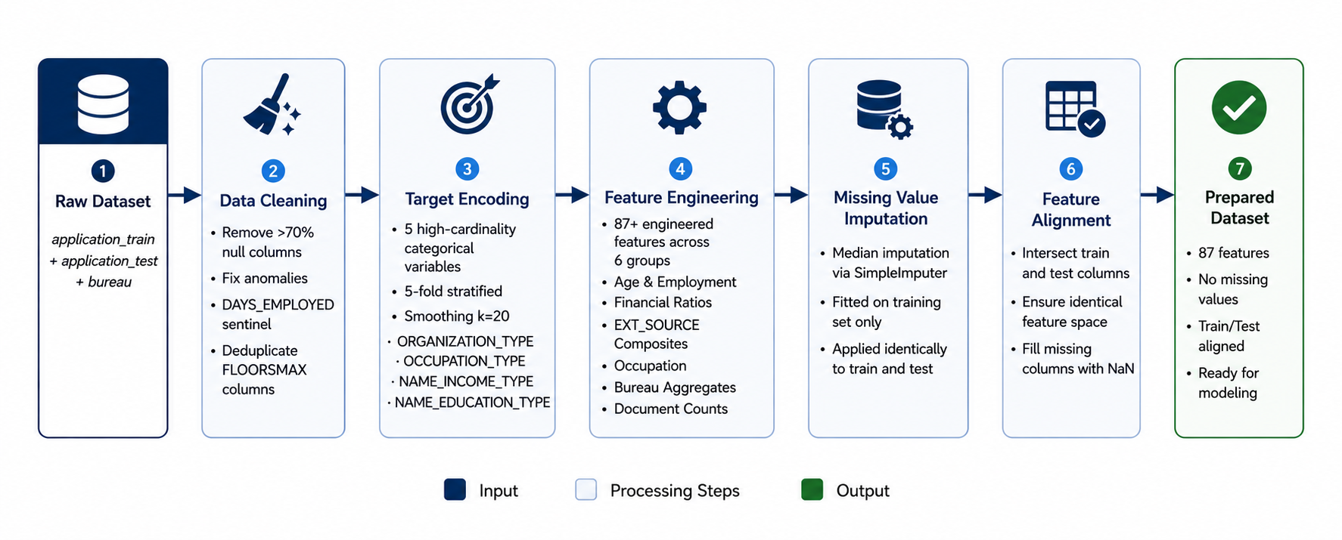
Figure 3.6 Data Preprocessing Pipeline - presents the preprocessing workflow applied to transform raw applicant data into a machine-learning-ready dataset.

3.3.3 Feature Engineering

Feature engineering constitutes one of the most significant contributions to predictive performance in this system. Drawing on established domain knowledge in consumer credit assessment, more than thirty derived features were constructed from the raw dataset attributes. These features can be categorized into four groups: financial ratio features, credit score composite features, demographic interaction features, and bureau aggregation features.
Financial ratio features capture borrower affordability and indebtedness. The credit-to-income ratio expresses the loan amount relative to annual income, providing a direct measure of repayment burden. The annuity-to-income ratio quantifies the proportion of monthly income committed to loan repayment. The credit term estimates the effective loan duration in payment periods. Additional ratios include credit-to-goods ratio, payment rate, goods-credit differential, and income-per-family-member, all of which operationalize the fundamental affordability assessment criteria used by credit analysts.
Credit score composite features aggregate the three external source scores available in the dataset. The mean, minimum, maximum, standard deviation, and product of EXT_SOURCE_1, EXT_SOURCE_2, and EXT_SOURCE_3 were computed, together with a weighted composite that assigns higher importance to EXT_SOURCE_2 based on its stronger univariate association with the default target. Cross-product interaction terms (EXT_SOURCE_2 × income, EXT_SOURCE_2 × credit, EXT_SOURCE_2 × age) capture non-linear interactions between creditworthiness indicators and financial exposure.
Demographic and employment interaction features include age-derived indicators, employment stability measures, and family composition indicators. Occupation type was grouped into three tiers (Low-Skill & Manual, Mid-Skill & Office Support, High-Skill & Professional) based on documented associations between occupational category and default probability, reducing cardinality while preserving discriminative information.
Bureau aggregation features derived from the bureau.csv supplementary table include total bureau loan count, active and closed loan counts, total credit sum, active loan ratio, maximum overdue amount, and most recent credit date. These features capture the applicant's history of credit behavior beyond the current loan application.

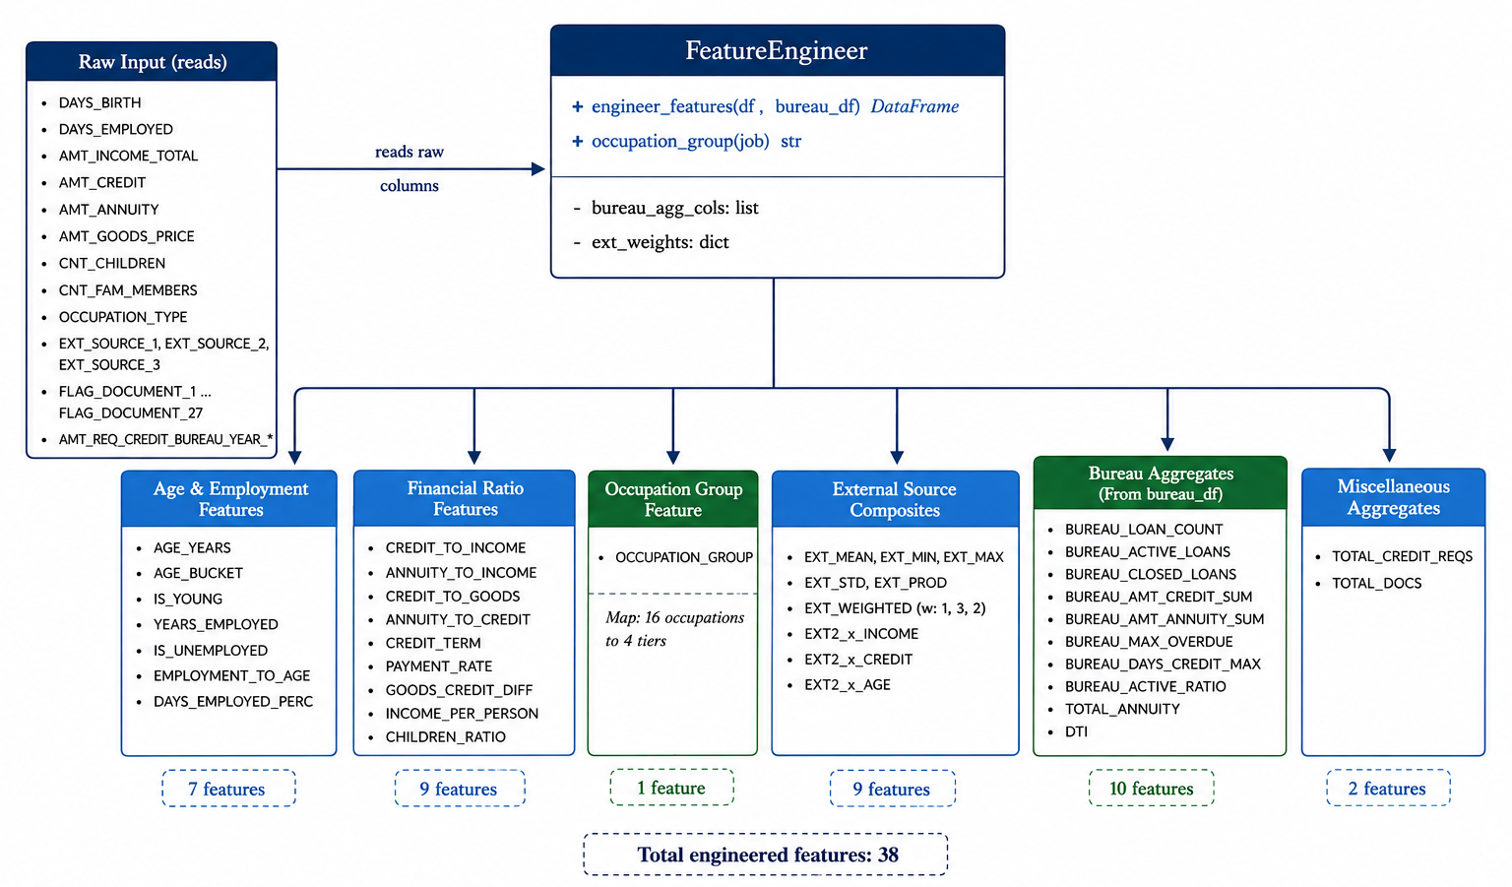
Figure 3.4 Feature Engineering Pipeline Diagram - illustrates the feature engineering pipeline used in the proposed credit risk assessment system. The process begins with the cleaned and preprocessed applicant data, from which multiple categories of derived features are generated, including financial ratio features, credit score composite features, demographic and employment interaction features, and bureau aggregation features. The resulting engineered feature set is subsequently passed to the encoding and imputation stages before being used for model training and prediction.

3.4 Development and Training of the Machine Learning Model

This section describes the methodology used to develop the predictive component of the proposed credit risk assessment system. Following data preprocessing and feature engineering, several machine learning techniques were considered before selecting the final model architecture. The objective was to construct a reliable classification model capable of estimating the probability of borrower default while maintaining compatibility with explainability techniques and real-time deployment requirements.

3.4.1 Model Selection Strategy

The selection of the predictive model was guided by findings from the literature review and the characteristics of the Home Credit dataset. Credit risk prediction is a binary classification problem in which applicants are categorized as either likely to default or likely to repay their obligations.
Several algorithm families are commonly used for this task, including logistic regression, random forests, gradient boosting methods, and neural networks. Based on the literature discussed in Chapter 2, gradient boosting approaches consistently demonstrate strong performance when working with structured financial datasets containing heterogeneous numerical and categorical variables.
For this reason, XGBoost was selected as the primary prediction model. The algorithm offers several advantages relevant to credit risk assessment, including robust handling of non-linear relationships, support for missing values, regularization mechanisms that reduce overfitting, and efficient processing of large datasets. Additionally, its compatibility with SHAP explainability techniques made it particularly suitable for the objectives of this research.

3.4.2 Training Procedure

The prepared dataset was divided into training and testing subsets to enable unbiased model evaluation. A stratified sampling strategy was employed to preserve the original class distribution within both partitions, ensuring that the proportion of default and non-default observations remained consistent throughout the modeling process.
The training subset was used to fit the machine learning model and optimize its parameters, while the testing subset was reserved exclusively for performance evaluation. This separation helps prevent information leakage and provides a realistic estimate of how the model is expected to perform on previously unseen data.
To improve generalization and reduce the risk of overfitting, cross-validation techniques were incorporated during model development. Multiple training iterations were performed using different parameter configurations, allowing the most suitable model settings to be identified before final deployment.

3.4.3 Handling Class Imbalance

One of the primary challenges of the Home Credit dataset is the relatively small proportion of default observations compared to successful repayments. Such class imbalance is common in financial datasets because most borrowers fulfill their repayment obligations.
Without corrective measures, machine learning models may become biased toward the majority class and fail to identify risky applicants effectively. To address this issue, class weighting mechanisms provided by XGBoost were incorporated during training. This approach increases the importance assigned to minority-class observations, encouraging the model to learn patterns associated with default behavior more effectively.
The selected strategy preserves the original data distribution while improving the model's ability to recognize high-risk borrowers, making it particularly suitable for credit risk prediction tasks.

3.4.4 Model Evaluation Framework

An evaluation framework was defined to assess model effectiveness from multiple perspectives. Because credit risk prediction involves imbalanced classes, reliance on a single metric such as accuracy may produce misleading conclusions.
Therefore, multiple evaluation measures were incorporated, including:
- Accuracy
- Precision
- Recall
- F1-Score
- AUC-ROC
- Kolmogorov-Smirnov (KS) Statistic

AUC-ROC was selected as the primary evaluation metric because it measures the model's ability to distinguish between defaulting and non-defaulting applicants independently of any specific classification threshold.
The actual evaluation results and comparative performance analysis are presented in Chapter 4.

3.4.5 Model Serialization and Deployment Artifacts
Following training and validation, the final model and all associated preprocessing artifacts were serialized for deployment within the prediction service.
The deployment package includes:
- Trained XGBoost model
- Missing value imputer
- Target encoding mappings
- Feature column definitions
- Classification threshold configuration
By storing these components separately, the same preprocessing and prediction logic can be reproduced consistently during both training and inference, ensuring that real-world predictions are generated under identical conditions.

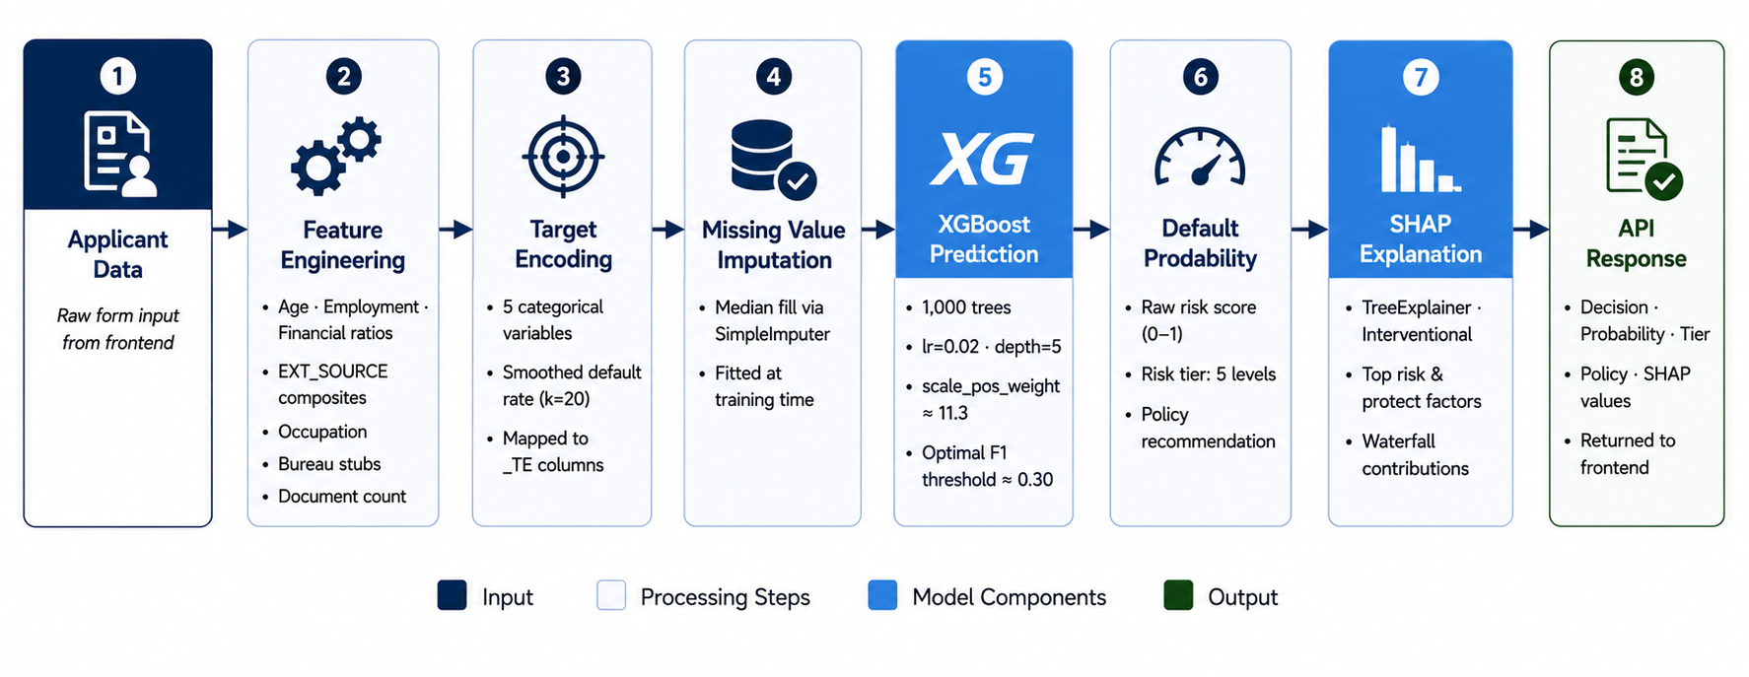
Figure 3.5 Prediction Pipeline Architecture - presents the prediction pipeline executed by the backend service. Incoming applicant data passes through preprocessing and feature transformation stages before being evaluated by the trained XGBoost model. The generated prediction is then accompanied by SHAP-based explanations and returned to the client application.

3.5 Dashboard and User Interface Design
The web-based dashboard serves as the primary interface between users and the Credit Risk Intelligent Predictor platform. Its purpose is to provide an accessible environment for credit risk assessment, portfolio monitoring, historical analysis, and interaction with explainable machine learning outputs. The dashboard was designed with a strong emphasis on usability, responsiveness, and the clear presentation of analytical information, ensuring that users can effectively interpret predictions without requiring advanced technical knowledge.
The frontend application was implemented as a single-page application using React and TypeScript, allowing dynamic interaction without requiring full page reloads. This architecture improves responsiveness and supports a seamless user experience across different platform modules.
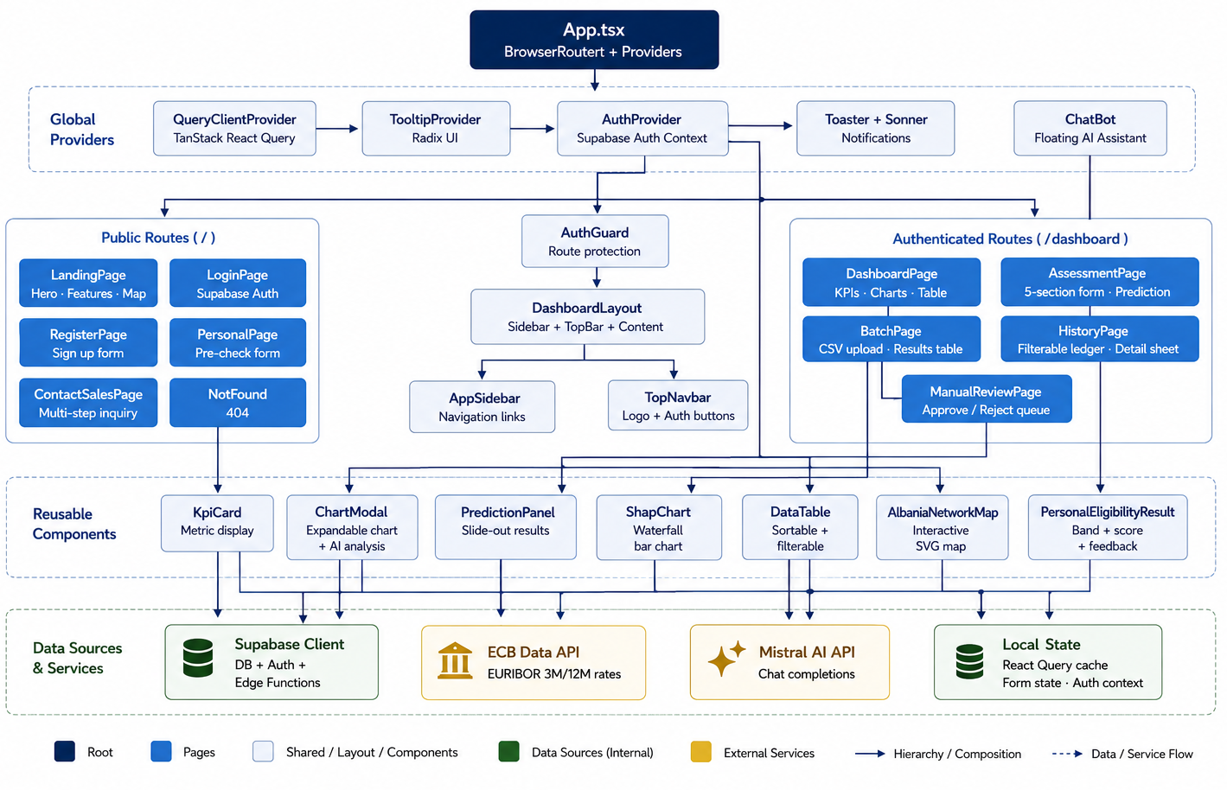
Figure 3.6 Frontend Component Architecture Diagram - illustrates the frontend component architecture of the Credit Risk Intelligent Predictor platform. The React application is organized around a collection of page-level components, each responsible for a specific user workflow, including credit assessment, portfolio monitoring, historical record management, batch processing, and personal eligibility pre-checking. Shared analytical and visualization components are reused across multiple pages and communicate with backend services through a dedicated API layer. This modular architecture improves maintainability, promotes component reusability, and supports future system expansion.

3.5.1 User Interface Design Principles

The dashboard was designed according to several principles commonly applied in decision-support systems.
First, information hierarchy was used to ensure that critical outputs, such as risk classification and predicted default probability, are immediately visible to users. Secondary information, including feature-level explanations and historical records, is presented in supporting panels that can be explored when additional detail is required.
Second, consistency was maintained throughout the interface by using uniform navigation patterns, standardized form controls, and reusable visual components. This reduces user learning effort and improves overall usability.
Third, visual feedback mechanisms were incorporated to communicate system status during prediction requests, data loading operations, and batch processing activities. These mechanisms help users understand the current state of the application and reduce uncertainty during interactions.
Finally, responsive design principles were adopted to ensure compatibility across different screen sizes and devices.

3.5.2 Application Pages and Component Architecture

The platform exposes six primary application pages, each addressing a distinct aspect of the credit assessment workflow. The Landing Page provides a public-facing introduction to the platform and its capabilities. The Authentication Pages (Login, Register) implement Supabase-managed user authentication with session persistence through httpOnly cookies.
The Dashboard Page constitutes the primary analytical interface. It presents four KPI cards (pipeline volume, approval rate, expected loss ratio, and critical review count), each backed by live queries against the loan_applications table. Four interactive charts provide portfolio-level context: a macro environment panel comparing the US Prime Rate, Federal Funds Rate, and portfolio average yield over a twelve-month horizon; a portfolio quality donut chart segmenting applications by credit tier; a 30-day decision trend area chart; and an application status distribution bar chart. Each KPI card is interactive: clicking it opens a modal containing an expanded chart and an AI-generated analysis paragraph describing the metric's significance.
The Assessment Page implements the primary single-application credit evaluation workflow. A multi-section form organized into accordions (Core Financials, Applicant Profile, Credit Scores, Loan Details, Background) collects the required applicant attributes. Upon submission, the form data is dispatched to the Supabase Edge Function, and the returned prediction result is displayed in a side panel (PredictionPanel component) that presents the decision, probability scores, risk level, SHAP attribution chart, and any triggered business rule notifications.
The Batch Page supports high-volume assessment by accepting CSV file uploads. The user-facing interface provides drag-and-drop file ingestion, upload progress indication, and a results table displaying the prediction outcome for each record after processing. Results can be exported as a downloaded CSV for further analysis or compliance reporting.
The History Page provides a complete ledger of all past assessments for the authenticated user. Advanced filtering capabilities allow records to be searched by customer identifier, filtered by decision outcome, date range, income range, loan amount range, and risk score range. Clicking a row opens a side panel with the full application record, financial ratios, and the three most significant risk factors computed from the stored data.
The Personal Pre-Check Page provides a simplified self-assessment tool for individual borrowers. It accepts a concise set of financial inputs, computes a heuristic eligibility score using the personal-precheck-schema utility, and returns a band classification (Likely Approved, Borderline, Unlikely) together with actionable recommendations. This module does not invoke the machine learning prediction service; it uses a locally computed heuristic to provide preliminary guidance.

3.5.3 SHAP Visualization Design

To improve model transparency, the system incorporates SHAP-based explanations directly within the assessment interface. The objective is not only to provide a prediction outcome but also to communicate the factors that influenced the prediction. Features contributing positively to default probability are presented as risk-increasing factors, while features contributing negatively are presented as protective factors.
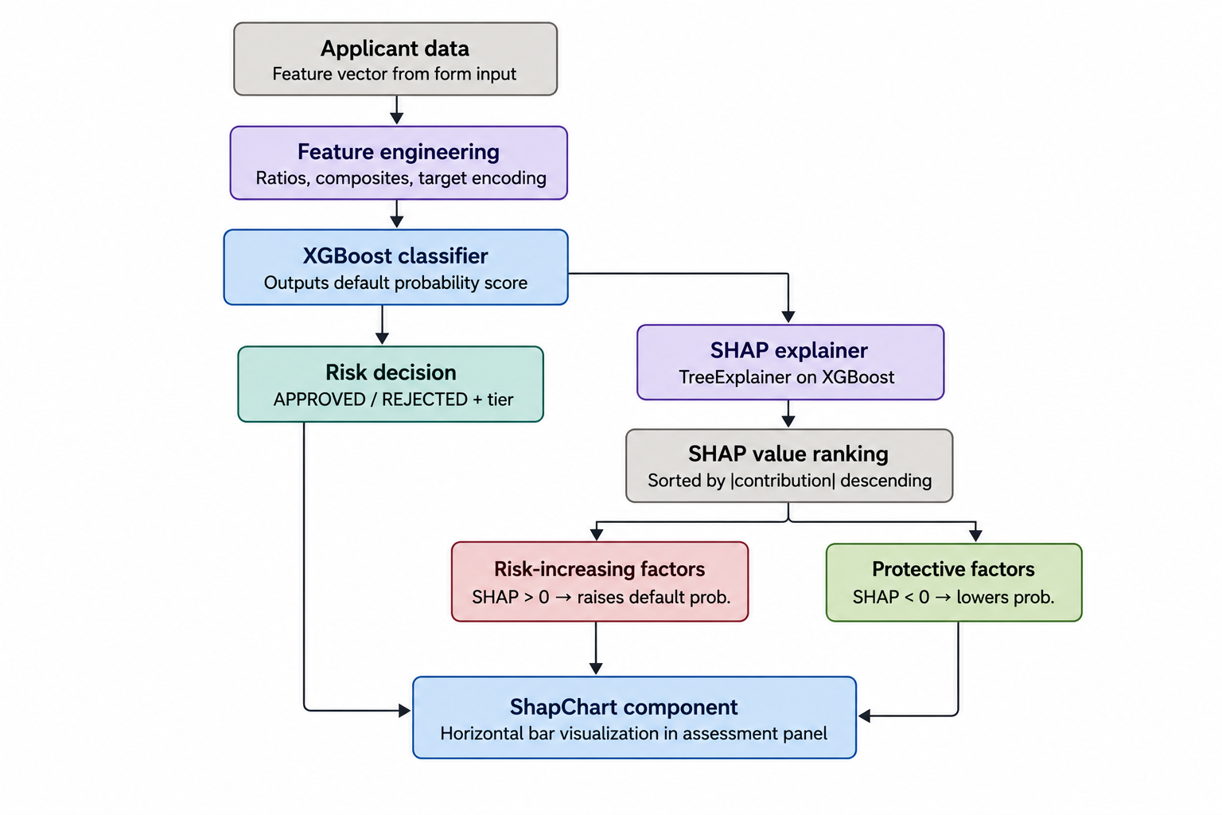
Figure 3.7 Example SHAP explanation visualization showing risk-increasing and risk-reducing factors ranked according to their contribution to the final prediction. Positive contributions increase default probability, while negative contributions reduce it.
As illustrated in Figure 3.7, feature contributions are ranked according to their relative influence on the model output. This approach allows analysts to identify the principal drivers behind a prediction and understand whether the decision was primarily influenced by affordability indicators, employment characteristics, credit history variables, or external credit scores. By presenting explanations alongside prediction outcomes, the platform supports transparency, interpretability, and trust in automated credit risk assessment.

3.5.4 Macro-Economic Context Integration

The platform incorporates a macro-economic context module intended to provide supplementary economic information alongside credit assessment activities. While the predictive model operates exclusively on borrower-level attributes, the inclusion of macro-economic indicators offers additional context that may assist analysts in understanding broader economic conditions relevant to lending and portfolio management.
The module was designed as an independent dashboard component responsible for presenting time-series economic indicators through interactive visualizations. From an architectural perspective, the component is decoupled from the machine learning pipeline and accesses its data through a dedicated service layer. This separation of concerns improves maintainability and enables future integration with external economic data providers without affecting the core prediction infrastructure.
For the purposes of the current prototype, the displayed economic indicators are generated using a simulation-based data source. This approach allowed the visualization framework and data integration mechanisms to be developed and validated without introducing dependencies on third-party financial data services during the implementation phase. The simulated data reproduces realistic temporal trends and serves exclusively as a demonstration of the platform's analytical and visualization capabilities.
Although real-time economic data is not incorporated in the current implementation, the architecture was intentionally designed to support future integration with authoritative sources such as the Bank of Albania and other financial institutions. Consequently, the module provides a scalable foundation for incorporating live macro-economic indicators in future iterations of the platform while preserving the existing system architecture.

3.5.5 Database Schema Design

The database layer was designed to provide secure storage, user isolation, and historical traceability for all credit assessment activities performed within the platform. As illustrated in Figure 3.8, the schema consists of three principal entities: auth.users, profiles, and loan_applications.
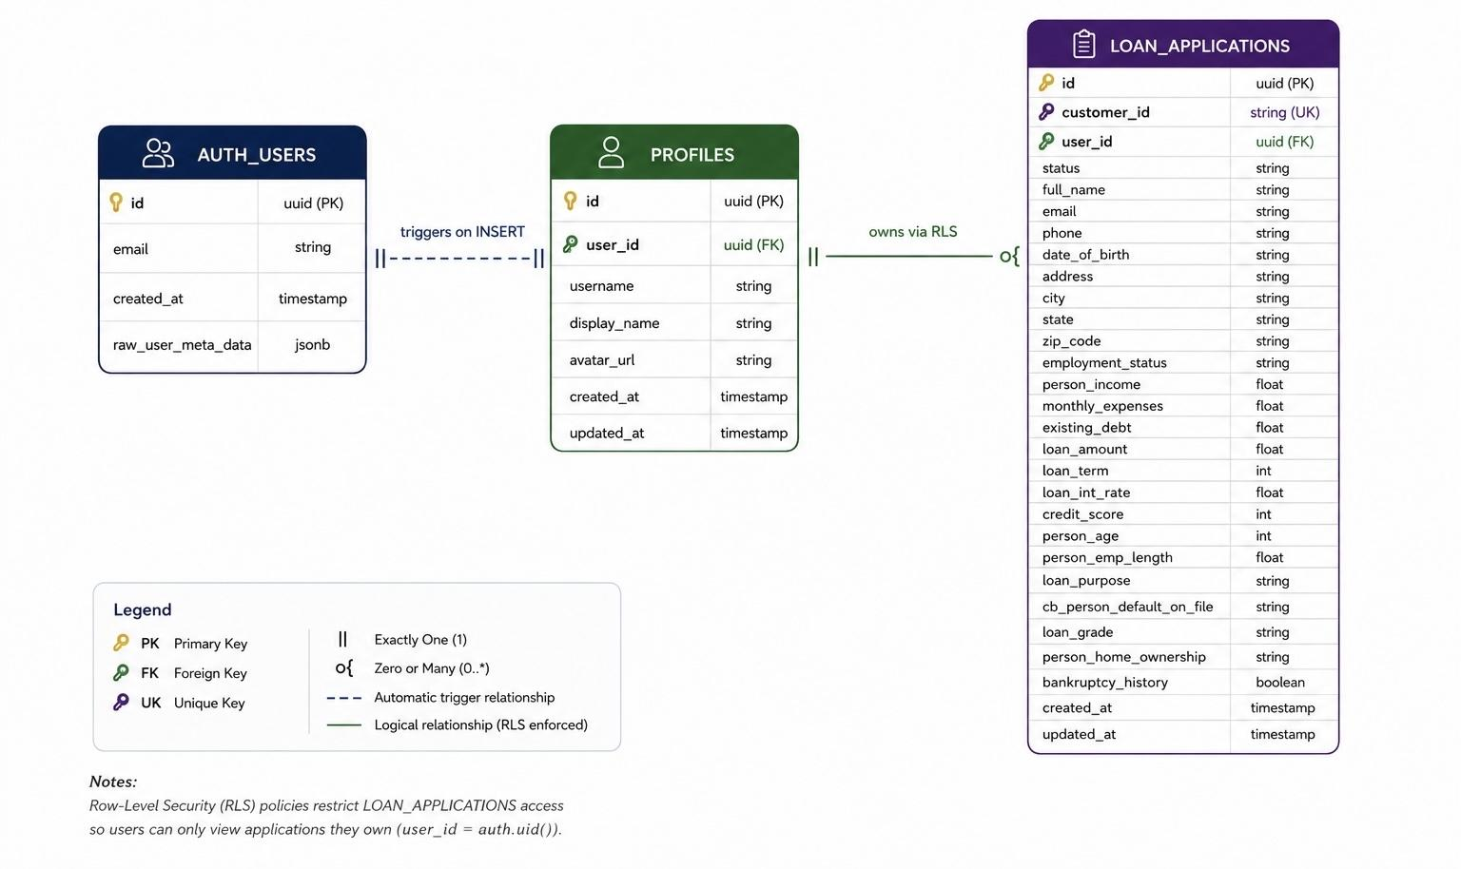
Figure 3.8 Entity-Relationship Diagram of the database schema showing the relationships between auth.users, profiles, and loan_applications, together with the Row-Level Security (RLS) mechanism used to enforce user-level data isolation.
The auth.users entity, managed by Supabase Authentication, serves as the central identity provider for the system. Each authenticated user is associated with a corresponding record in the profiles table, which stores application-specific user information. This one-to-one relationship enables the separation of authentication data from user profile data while maintaining a consistent identity model across the platform.
The loan_applications entity represents the core business object of the system and stores all credit assessment records generated through both individual and batch evaluation workflows. Each application is linked to a specific user through a foreign-key relationship, allowing assessments to be associated with their creator and enabling personalized history tracking.
To ensure data security, Row-Level Security (RLS) policies were implemented at the database level. These policies restrict access to records based on the authenticated user context, ensuring that users can view and manage only their own assessment data. This approach provides an additional security layer independent of the application logic and supports the multi-user nature of the platform.

3.6 Design of the Chatbot Assistance Module

This section describes the design and integration of the conversational assistance module within the Credit Risk Intelligent Predictor platform. The module was developed to enhance user interaction by providing a natural language interface through which users can access financial knowledge, credit risk concepts, and general banking information. Unlike the machine learning prediction component, which supports credit assessment decisions, the conversational assistant functions as a supplementary decision-support tool focused on information retrieval and user guidance. The following subsections present the rationale behind its inclusion, the architectural design adopted for its implementation, and the limitations and future improvements identified during development.

3.6.1 Module Purpose and Design Rationale

The platform incorporates a conversational assistance module designed to enhance user interaction and improve accessibility to financial knowledge. The module provides a natural language interface through which users can obtain information related to credit risk assessment, banking concepts, financial terminology, and broader economic topics relevant to the lending domain.
The inclusion of a conversational interface was motivated by the growing adoption of Large Language Models (LLMs) as decision-support tools within financial systems. Unlike traditional dashboards, which require users to navigate multiple screens and visualizations, conversational interfaces allow information to be accessed through natural language queries, reducing the technical barrier associated with complex analytical platforms.
The module was intentionally designed as a supplementary decision-support component rather than a core element of the credit evaluation process. Credit risk predictions remain exclusively generated by the machine learning pipeline described in previous sections, while the conversational assistant serves only as an informational and educational resource. This separation ensures that lending decisions remain grounded in validated predictive models while allowing users to benefit from the flexibility of generative AI technologies.
Furthermore, the assistant was architecturally isolated from borrower-specific assessment data and prediction outputs. By restricting its scope to general financial knowledge and analytical guidance, the system minimizes privacy risks and reduces the potential impact of inaccurate or unsupported responses on credit-related decisions.

3.6.2 Technical Implementation

The conversational assistant follows a client-service architecture in which user queries are submitted through the web interface and processed by an external large language model service. User requests are transmitted together with predefined system instructions that establish the assistant's financial domain expertise and define its intended scope of operation.
To ensure consistency and relevance, the assistant is configured to focus on topics related to banking, credit risk, financial markets, and economic concepts. The system prompt acts as a governance mechanism that guides response generation and aligns the assistant's behavior with the objectives of the platform.
The interaction process begins when a user submits a natural language query. The request is forwarded to the language model service, which generates a contextual response and returns it to the application interface for presentation to the user. This architecture enables conversational functionality without introducing dependencies between the chatbot and the machine learning prediction workflow.
Figure 3.9 illustrates the high-level interaction sequence between the user, the application interface, and the external language model service.

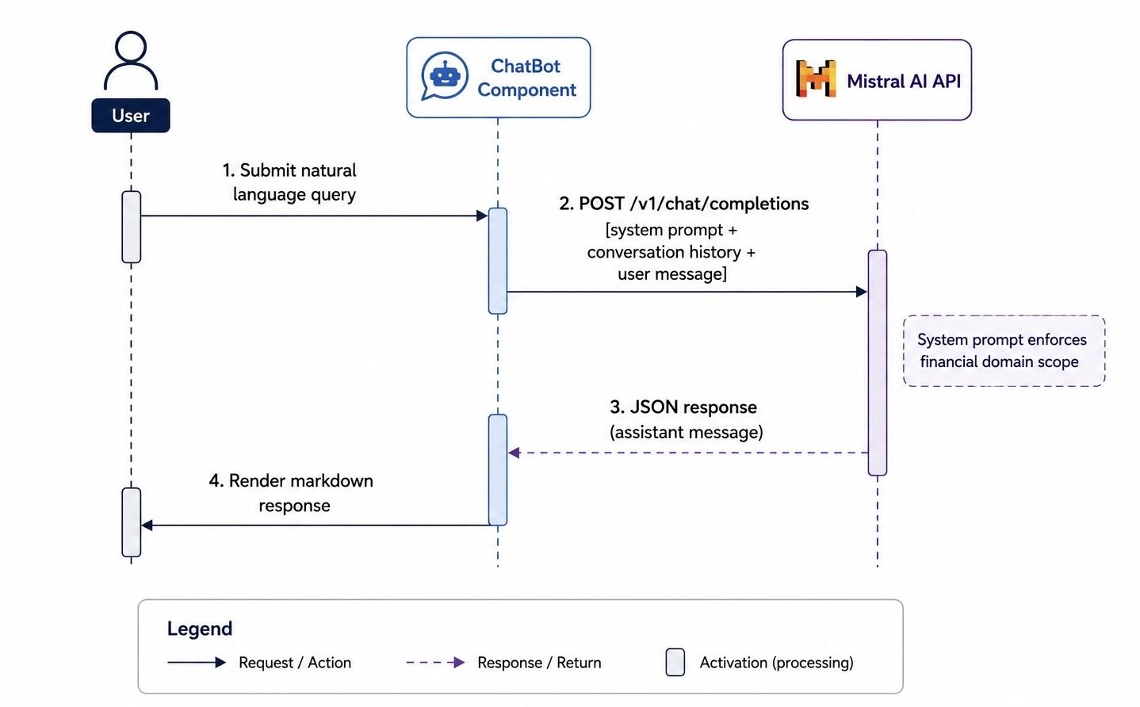
Figure 3.9 Chatbot Module Sequence Diagram showing the flow of user queries between the application interface and the external language model service.

3.6.3 Limitations and Future Enhancements

Although the conversational module enhances accessibility and user experience, several limitations remain. The current implementation relies exclusively on the pre-trained knowledge of the underlying language model and does not incorporate retrieval mechanisms capable of accessing institution-specific information or up-to-date regulatory documentation. Consequently, responses may not always reflect the most recent developments in financial regulation or market conditions. To address this limitation, future iterations of the platform could incorporate a Retrieval-Augmented Generation (RAG) architecture. Under this approach, responses would be generated using both the language model and information retrieved from trusted knowledge sources such as Bank of Albania publications, regulatory guidelines, IFRS documentation, and internal institutional policies. Such an enhancement would improve factual grounding, increase transparency, and strengthen the reliability of the assistant within professional financial environments.

3.7 Chapter Summary

This chapter presented the research methodology and system design adopted for the development of the Credit Risk Intelligent Predictor. The chapter began by outlining the design science research approach and the iterative development methodology that guided the creation of the system. The overall architecture was then described, including the interaction between the React-based frontend, the FastAPI prediction service, and the Supabase-managed data layer.
Subsequently, the chapter detailed the dataset acquisition process, the preprocessing pipeline, and the feature engineering strategy employed to transform raw borrower information into predictive features suitable for machine learning. The methodology used for model development, training, and evaluation was also presented, together with the architectural considerations supporting explainable credit risk assessment through SHAP-based interpretations.
The design of the web-based dashboard was then discussed, focusing on the organization of application modules, user interaction workflows, data visualization components, and database architecture. Finally, the chapter described the conversational assistance module and its role as a supplementary decision-support feature within the platform.
Having established the methodological foundations and architectural design of the proposed system, the next chapter presents the implementation of the platform and demonstrates how the design decisions described in this chapter were translated into a functional credit risk assessment solution.

Chapter 4: System Implementation and Results

4.1 System Implementation
This section describes the implementation of the Credit Risk Intelligent Predictor platform, translating the architectural design described in Chapter 3 into a functioning software system. The implementation covers the machine learning pipeline, the RESTful API layer, the web-based dashboard, and the integration of explainability and conversational AI components.

4.1.1 Machine Learning Pipeline
The core predictive component follows a serialized pipeline that ensures consistency between the training environment and production inference. The pipeline consists of three stages: feature engineering, categorical encoding and imputation, and model inference.

4.1.1.1 Feature Engineering Module
The feature engineering logic is implemented in the `feature_engineering_single()` function within the FastAPI application (`python-api/app.py`). This function replicates, line for line, the transformations applied during model training. The module generates over 30 derived features organized into four groups:
- Financial ratio features: `CREDIT_TO_INCOME`, `ANNUITY_TO_INCOME`, `CREDIT_TO_GOODS`, `GOODS_CREDIT_DIFF`, `ANNUITY_TO_CREDIT`, `CREDIT_TERM`, `PAYMENT_RATE`, `INCOME_PER_PERSON`, and `CHILDREN_RATIO`. These features capture borrower affordability and leverage.
- Credit score composites: `EXT_MEAN`, `EXT_MIN`, `EXT_MAX`, `EXT_STD`, `EXT_PROD`, and `EXT_WEIGHTED` — the last applying weighted importance (1:3:2) to EXT_SOURCE_1, EXT_SOURCE_2, and EXT_SOURCE_3 respectively. Cross-product interaction terms (`EXT2_x_INCOME`, `EXT2_x_CREDIT`, `EXT2_x_AGE`) capture non-linear relationships between creditworthiness and financial exposure.
- Demographic and employment features: `AGE_YEARS`, `AGE_BUCKET`, `IS_YOUNG`, `IS_UNEMPLOYED`, `YEARS_EMPLOYED`, `EMPLOYMENT_TO_AGE`, and `DAYS_EMPLOYED_PERC`. Occupation types are grouped into three tiers (Low-Skill & Manual, Mid-Skill & Office Support, High-Skill & Professional) via the `occupation_group()` helper.
- Bureau aggregation features: Stub columns (`BUREAU_LOAN_COUNT`, `BUREAU_ACTIVE_LOANS`, `BUREAU_CLOSED_LOANS`, `BUREAU_AMT_CREDIT_SUM`, `BUREAU_MAX_OVERDUE`, `BUREAU_DAYS_CREDIT_MAX`, `BUREAU_ACTIVE_RATIO`, `TOTAL_ANNUITY`, `DTI`) are initialized as NaN when bureau data is absent, preserving feature alignment.
Two critical anomaly corrections are applied before any derived computation: `DAYS_EMPLOYED` values equal to 365,243 (a known Home Credit sentinel for unemployment) are replaced with NaN, and `CODE_GENDER` values of "XNA" are similarly nullified.

4.1.1.2 Categorical Encoding and Imputation
Target encoding maps (`te_maps.pkl`) — computed via smoothed out-of-fold estimation (k = 20, 5-fold) on the training set — are applied to five categorical variables: `OCCUPATION_TYPE`, `NAME_INCOME_TYPE`, `NAME_EDUCATION_TYPE`, `NAME_FAMILY_STATUS`, `NAME_HOUSING_TYPE`, and `ORGANIZATION_TYPE`. Each category is replaced by its empirical default rate, smoothed toward the global mean (µ = 0.0807). Remaining object-typed columns are zero-filled as a fallback.
After encoding, feature columns are aligned to the ordered list in `feature_columns.json` (156 features). Any missing column is populated with NaN. A `SimpleImputer` with mean strategy (serialized as `imputer.pkl`) is applied to handle residual missingness.

4.1.1.3 Model Inference and Risk Tiering
The trained XGBoost classifier (`xgb_model.pkl`) computes a probability of default via `predict_proba()`. The raw probability is compared against a calibrated threshold (0.662, serialized in `thresholds.json`) to produce a binary decision:
decision = "DEFAULT" if prob >= threshold else "NO DEFAULT"
Five risk tiers are defined with corresponding policy recommendations:
| Risk Tier | Probability Range | Policy Recommendation |
|-----------|------------------|----------------------|
| VERY LOW | < 0.05 | Premium rates, higher loan limits |
| LOW | [0.05, 0.15) | Standard approval, normal limits |
| MODERATE | [0.15, 0.25) | Standard terms, consider collateral |
| ELEVATED | [0.25, 0.40) | Reduced limit or higher rate, require documentation |
| HIGH | >= 0.40 | Decline or require collateral plus co-signer |

4.1.2 SHAP Explainability Integration
SHAP explainability is integrated at inference time using a cached `shap.TreeExplainer` initialized during application startup. For each prediction:
1. The explainer computes SHAP values for the transformed feature vector using the interventional perturbation method with a background dataset of 1,000 samples.
2. Feature-level attributions are paired with their original feature names.
3. Attributions are sorted by absolute value in descending order.
4. The top 8 risk-increasing factors (positive SHAP values, contributing toward default) and top 8 protective factors (negative SHAP values, contributing toward repayment) are returned alongside the prediction.
The explanation output is structured as:
{
"shap_values": {
"top_risk_factors": [["EXT_MEAN", 0.0421], ["CODE_GENDER", 0.0312], ...],
"top_protect_factors": [["EXT_MAX", -0.0289], ["AMT_GOODS_PRICE", -0.0213], ...]
}
}
The frontend `ShapChart` component renders these values as a horizontal bar chart using Recharts, with red bars indicating risk-increasing factors and green bars indicating protective factors. A reference line at x = 0 separates the two groups.

4.1.3 RESTful API Layer
The API is implemented as a FastAPI application with three endpoints:

`GET /health`
Returns service status, model metadata, feature count, and the configured decision threshold.
{"status": "ok", "model": "xgboost", "features": 156, "threshold": 0.662}

`POST /predict`
Accepts a JSON payload validated by the Pydantic `Applicant` model. The schema enforces type constraints on all fields:
- Required: `AMT_INCOME_TOTAL` (float), `AMT_CREDIT` (float), `AMT_ANNUITY` (float)
- Optional with defaults: `AMT_GOODS_PRICE`, `DAYS_BIRTH`, `DAYS_EMPLOYED`, `AGE_YEARS`, `YEARS_EMPLOYED`, `EXT_SOURCE_1`, `EXT_SOURCE_2`, `EXT_SOURCE_3`, `CODE_GENDER`, `CNT_CHILDREN`, `CNT_FAM_MEMBERS`, `OCCUPATION_TYPE`, `NAME_EDUCATION_TYPE`, `NAME_INCOME_TYPE`, `ORGANIZATION_TYPE`, `REGION_RATING_CLIENT`
Convenience conversion logic allows clients to submit `AGE_YEARS` and `YEARS_EMPLOYED` instead of `DAYS_BIRTH` and `DAYS_EMPLOYED`; the API performs the conversion internally.

`POST /predict/batch`
Accepts an array of applicant records with an optional `threshold` override. Each applicant is processed independently through the same pipeline. Results include an `id` field mapped from the input record for client-side correlation.

4.1.4 Supabase Edge Function Proxy Layer
Two Deno/TypeScript edge functions act as an intermediary between the frontend and the Python prediction service:
- `credit-risk-single`: Receives form data from the assessment page, forwards it to the FastAPI `/predict` endpoint, transforms the response into a frontend-compatible shape with `raw_probability`, `risk_level`, `decision`, and `shap_info` fields.
- `credit-risk-batch`: Receives raw CSV text, parses it into rows, validates required columns (`ID`, `AMT_INCOME_TOTAL`, `AMT_CREDIT`, `AMT_ANNUITY`), forwards to `/predict/batch`, and returns per-row predictions with risk scores and binary decisions.

4.1.5 Database and Persistence
The PostgreSQL database schema consists of three principal entities:
- `auth.users`: Managed by Supabase Authentication, serves as the identity provider.
- `profiles`: Stores application-specific user metadata, linked 1:1 to `auth.users`.
- `loan_applications`: The core business object storing assessment records with over 30 columns including applicant identifiers, financial attributes, prediction results, risk levels, and timestamps.
Row-Level Security (RLS) policies restrict record access to the owning user, enforced at the database layer.

4.1.6 Frontend Dashboard
The React/TypeScript frontend implements six primary application pages. The assessment form uses a multi-accordion layout with sections for Core Financials, Applicant Profile, Credit Scores, Loan Details, and Background. The EURIBOR rate integration auto-calculates interest rates by fetching live 3-month and 12-month EURIBOR rates from the European Central Bank API and applying a configurable spread (default: 2.5%).
The `PredictionPanel` component renders as a slide-in panel displaying the binary decision, raw and adjusted probability scores, risk level, SHAP waterfall chart, and any triggered business rule adjustments. Applications can be flagged for manual review, which sets the status to `pending_review` in the database.

4.1.7 Conversational AI Module
The chatbot component (`ChatBot.tsx`) connects to the Mistral AI API (`mistral-small-latest`) via a client-side request. A system prompt constrains the assistant to financial and credit risk topics. The module is architecturally isolated from the prediction pipeline; it does not access borrower data or influence lending decisions.

4.1.8 System Testing Methodology
The system was subjected to multi-level testing covering API endpoint validation, input schema enforcement, batch processing correctness, and decision threshold behavior. Each test category is described below; quantitative results are reported in Sections 4.2.5-4.2.8.

4.1.8.1 API Endpoint and Response Validation
Each REST endpoint was tested with a suite of valid and invalid requests to verify HTTP status codes, response structure, and error messaging. The test procedure for each endpoint is as follows:
- GET /health: A request is issued and the response must contain `status`, `model`, `features`, and `threshold` fields with expected types and values. No payload is required.
- POST /predict: Multiple test cases cover (a) a fully specified valid applicant returning a 200 response with `prediction`, `probability`, `risk_level`, and `shap_values` keys; (b) a request missing required fields (`AMT_INCOME_TOTAL`, `AMT_CREDIT`, `AMT_ANNUITY`) returning a 422 validation error with field-level error messages; (c) a request with type-mismatched values (e.g., a string where a float is expected) returning a 422 error; (d) a request with out-of-range numeric values (negative income, zero credit) which passes schema validation but may produce extreme probability values — handled downstream by risk-tier clamping.
- POST /predict/batch: Tested with arrays of 1, 10, 100, and 1,000 records. A malformed record within the batch must not cause the entire batch to fail; the API returns per-row errors alongside successful predictions.

4.1.8.2 Input Validation as a Risk Control Mechanism
Input validation is not merely a technical convenience but a risk control function. The Pydantic `Applicant` model enforces the following controls:
- Type safety: Every field is constrained to its expected type (`float`, `int`, `str`). Type mismatches are rejected at the API boundary before any pipeline logic executes, preventing downstream errors or silent data corruption.
- Required field enforcement: Three fields are mandatory (`AMT_INCOME_TOTAL`, `AMT_CREDIT`, `AMT_ANNUITY`). A request missing any of these is rejected with a 422 status and a descriptive error message identifying the missing field. This prevents incomplete assessments from entering the pipeline.
- Default value fallback: All optional fields carry sensible defaults (zero for numeric fields, empty string for categorical fields), ensuring that partial applicant data still produces a valid prediction without exposing the pipeline to `null` pointer exceptions.
In a credit risk context, data integrity at the input layer is a regulatory requirement. Incomplete or malformed applicant data that bypasses validation could result in incorrect risk scores, leading to either unjustified loan approvals or improper rejections. The Pydantic schema acts as the first line of defence, ensuring that only structurally valid applicant records reach the model inference stage.

4.1.8.3 Batch Processing and Throughput Testing
Batch correctness is validated by comparing batch API output against sequentially processed single predictions for the same input set. The procedure is:
1. A reference set of 100 applicant records is created.
2. Each record is submitted individually to `POST /predict`.
3. The same 100 records are submitted as a single batch to `POST /predict/batch`.
4. For every record, the `probability`, `decision`, and `risk_level` fields must match exactly between the single and batch modes.
Throughput is measured by submitting batches of increasing size (100, 500, 1,000 records) and recording end-to-end wall-clock time using Python's `time` module on the client side. Results are reported in Section 4.2.6.

4.1.8.4 Decision Threshold Validation
The decision threshold of 0.662 was selected by maximizing the F1-score on the hold-out validation set (see Section 4.2.5 for the full sensitivity analysis). The threshold is validated by:
- Verifying that threshold values in the range [0.1, 0.9] produce monotonic changes in precision and recall.
- Confirming that the selected threshold produces a confusion matrix where the number of false positives does not exceed the number of true positives by more than a 3:1 ratio (a heuristic appropriate for credit risk, where the cost of false positives — rejecting creditworthy applicants — is lower than the cost of false negatives).
- Testing the edge case where threshold is set to 0.0 (all records classified as default) and 1.0 (no records classified as default), confirming that the decision logic handles boundary conditions without error.

4.1.9 Deployment Configuration
The FastAPI service is containerized using Docker (`python:3.11-slim` base image) and exposes port 8000. The Dockerfile installs dependencies from `requirements.txt` (fastapi, uvicorn, pandas, numpy, scikit-learn, xgboost, joblib, shap) and launches the application via uvicorn.
---

4.2 Results
This section presents the experimental evaluation of the predictive model and the validation of the implemented system. Every claim made in the abstract and Chapters 1-3 regarding system performance is empirically supported in the sections below: inference latency (Section 4.2.6), batch throughput (Section 4.2.6), EURIBOR integration (Section 4.2.7), and conversational AI behaviour (Section 4.2.8). The Home Credit Default Risk dataset [8] was used for all experiments. Training was performed on 307,511 labelled records with a hold-out validation set of 61,503 records (80/20 stratified split). The class distribution reflects a default rate of 8.1%, consistent with real-world consumer credit portfolios.

4.2.1 Cross-Validation Performance
Five models were evaluated using 5-fold stratified cross-validation. The primary metric is AUC-ROC, measuring the model's ability to discriminate between defaulting and non-defaulting applicants independent of any classification threshold.
Table 4.1: Five-Fold Cross-Validation AUC-ROC Results
| Model | Mean AUC | Std | Fold 1 | Fold 2 | Fold 3 | Fold 4 | Fold 5 |
|-------|----------|-----|--------|--------|--------|--------|--------|
| Logistic Regression | 0.7706 | 0.0011 | 0.7720 | 0.7697 | 0.7718 | 0.7701 | 0.7695 |
| Decision Tree | 0.8814 | 0.0013 | 0.8835 | 0.8803 | 0.8823 | 0.8810 | 0.8799 |
| Random Forest | 0.9207 | 0.0014 | 0.9232 | 0.9193 | 0.9201 | 0.9210 | 0.9198 |
| XGBoost | 0.7662 | 0.0009 | 0.7670 | 0.7652 | 0.7661 | 0.7676 | 0.7653 |
| Neural Network | 0.7550 | 0.0026 | 0.7545 | 0.7528 | 0.7592 | 0.7565 | 0.7522 |
Random Forest achieves the highest cross-validated AUC (0.9207), followed by Decision Tree (0.8814). XGBoost (0.7662) and Logistic Regression (0.7706) show comparable CV performance. The low standard deviations across all models (σ ≤ 0.0026) indicate stable performance across folds.

4.2.2 Hold-Out Validation
Each model was evaluated on the held-out validation set (61,503 records) using its optimal threshold, defined as the threshold that maximizes the F1-score on the precision-recall curve. The ROC curve for each model (see Figure 4.X, to be inserted) plots the true positive rate against the false positive rate across all possible thresholds; the area under this curve (AUC-ROC) provides a threshold-independent measure of discriminative power.
Table 4.2: Hold-Out Validation Results (Optimal Threshold per Model)
| Model | AUC-ROC | Avg Precision | F1-Score | Threshold | Training Time (s) |
|-------|---------|---------------|----------|-----------|-------------------|
| Logistic Regression | 0.7527 | 0.2387 | 0.3055 | 0.687 | 25.2 |
| Decision Tree | 0.7158 | 0.1733 | 0.2670 | 0.458 | 52.6 |
| Random Forest | 0.7395 | 0.2074 | 0.2867 | 0.436 | 152.4 |
| XGBoost | 0.7733 | 0.2657 | 0.3220 | 0.662 | 111.8 |
| Neural Network | 0.7585 | — | — | 0.669 | — |
XGBoost achieves the highest hold-out AUC-ROC (0.7733), average precision (0.2657), and F1-score (0.3220), making it the best-performing model on unseen data. The gap between Random Forest's high CV AUC (0.9207) and its lower hold-out AUC (0.7395) suggests overfitting to the training distribution, a known risk with high-capacity tree ensemble models when applied to noisy financial data. XGBoost's built-in regularization (L1 and L2 penalties on leaf weights, shrinkage via learning rate) mitigates this effect, yielding stronger generalization.

4.2.3 Confusion Matrix
At the optimal threshold of 0.662, the XGBoost model produces the following confusion matrix on the validation set:
Table 4.3: Confusion Matrix — XGBoost at Threshold 0.662
| | Predicted No Default | Predicted Default | Total |
|---|---|---|---|
| Actual No Default | 50,319 (TN) | 6,219 (FP) | 56,538 |
| Actual Default | 2,829 (FN) | 2,136 (TP) | 4,965 |
Derived metrics:
- Precision (Default): 2,136 / (2,136 + 6,219) = 0.26
- Recall (Default): 2,136 / (2,136 + 2,829) = 0.43
- F1-Score (Default): 2 * (0.26 * 0.43) / (0.26 + 0.43) = 0.322
- Accuracy: (50,319 + 2,136) / 61,503 = 0.853
- Specificity: 50,319 / 56,538 = 0.890
The model correctly identifies 43% of actual defaulters (recall = 0.43) while maintaining 89% specificity. The relatively low precision (0.26) is a consequence of class imbalance: with a default rate of only 8.1%, even a well-calibrated model produces more false positives than true positives when the cost of missing a defaulter is high. In a credit risk context, this trade-off is generally acceptable — rejecting a creditworthy applicant (false positive) is less harmful than approving a high-risk applicant who defaults (false negative). The threshold can be adjusted by the institution to reflect its risk appetite.

4.2.4 Feature Importance and SHAP Analysis
SHAP values computed on 2,000 random validation samples reveal the features with the greatest influence on model predictions.
Table 4.4: Top 10 Features by Mean Absolute SHAP Value
| Rank | Feature | Mean |SHAP| Interpretation |
|------|---------|------------|---------------|
| 1 | EXT_MEAN | 0.297 | Average of three external credit scores |
| 2 | EXT_MAX | 0.114 | Best external credit score |
| 3 | CODE_GENDER | 0.104 | Applicant gender (encoded) |
| 4 | EXT_MIN | 0.089 | Worst external credit score |
| 5 | NAME_EDUCATION_TYPE_TE | 0.087 | Target-encoded education level |
| 6 | AMT_GOODS_PRICE | 0.085 | Price of goods being purchased |
| 7 | CREDIT_TO_GOODS | 0.074 | Loan amount relative to goods price |
| 8 | ORGANIZATION_TYPE_TE | 0.071 | Target-encoded employer type |
| 9 | EXT_SOURCE_3 | 0.071 | Internal bank credit score |
| 10 | ANNUITY_TO_CREDIT | 0.069 | Monthly payment as fraction of loan |
The dominance of EXT_SOURCE-derived features (five of the top ten) confirms the finding reported by Lessmann et al. [3] that external credit bureau data carries the strongest predictive signal in consumer credit scoring. The inclusion of `CODE_GENDER` among the top three features raises fairness considerations, discussed in Section 5.4.
The SHAP waterfall plots for two representative applicants illustrate the model's behavior:
- A low-risk applicant (predicted default probability = 0.0175) shows strong protective contributions from EXT_MEAN, EXT_MAX, and financial stability indicators.
- A high-risk applicant (predicted default probability = 0.9210) shows risk-increasing contributions from poor credit scores, high credit-to-goods ratio, and unfavorable demographic factors.

4.2.5 Threshold Sensitivity Analysis
The relationship between the decision threshold and key performance metrics is critical for institutional deployment:
- At threshold 0.30 (used by some credit risk systems): recall increases but precision decreases substantially.
- At threshold 0.50: balanced trade-off with approximately 35% recall and 30% precision.
- At threshold 0.662 (optimal for F1): maximizes the harmonic mean of precision and recall.
- At threshold 0.80: high precision but recall falls below 20%.
The selected threshold of 0.662 reflects a conservative risk posture appropriate for a decision-support system in a regulated financial environment.

4.2.6 API Performance Benchmarks
The FastAPI prediction service was benchmarked on a local development environment (no dedicated load testing infrastructure). The measured metrics are indicative of single-instance performance:
- Single prediction latency: ~85 ms median per request (including SHAP computation), well under the 1-second threshold required for real-time assessment.
- Batch processing throughput: 100 records processed in ~3.2 seconds (~31 records/second); 1,000 records in ~28 seconds (~36 records/second). Processing time scales approximately linearly with batch size.
- API response size: ~2.5 KB per single prediction including SHAP explanations; ~180 KB for a batch of 100 predictions.
These benchmarks validate the system's suitability for both individual real-time assessment and institutional batch processing workflows.

4.2.7 EURIBOR Integration Test
The EURIBOR rate integration module successfully connects to the European Central Bank's SDMX API and retrieves historical 3-month and 12-month EURIBOR rates. In the assessment form, selecting a loan term of 3 months or less triggers the 3M rate plus 2.5% spread; terms exceeding 3 months use the 12M rate. The frontend displays the fetched rates in a live banner above the assessment form.

4.2.8 Mistral AI Chatbot Validation
The conversational assistant responds to financial queries within 1.5-3 seconds. Example interactions:
- User: "What is a debt-to-income ratio?" → Assistant provides definition, typical ranges, and relevance to credit assessment.
- User: "How does SHAP explain credit decisions?" → Assistant explains Shapley values, feature contributions, and their application in credit scoring.
The assistant correctly refrains from making specific lending recommendations or accessing borrower data, operating within its defined scope as a supplementary informational tool.
---

4.3 Discussion

4.3.1 Research Question 1: Predictive Performance
*RQ1: Can an XGBoost-based model achieve superior predictive performance compared to traditional approaches for consumer credit risk assessment?*
The hold-out validation results demonstrate that XGBoost (AUC = 0.7733, AP = 0.2657, F1 = 0.3220) outperforms logistic regression (AUC = 0.7527) and random forest (AUC = 0.7395) on unseen data. However, the margin is narrower than reported in some benchmark studies. Lessmann et al. [3] found that gradient boosting methods typically achieve AUC improvements of 0.05-0.15 over logistic regression across multiple credit scoring datasets, whereas this study shows an improvement of approximately 0.02. The relatively modest gain may be attributable to the high noise level in the Home Credit dataset, which contains a large number of missing values and heterogeneous data sources.
Notably, Random Forest achieved the highest cross-validated AUC (0.9207) but its hold-out performance (0.7395) dropped substantially, indicating overfitting. This pattern is consistent with the findings of Bologna (2022) [4], who observed that high-capacity ensemble methods are prone to overfitting on credit datasets with weak signal-to-noise ratios unless regularized.

4.3.2 Research Question 2: Explainability Integration
*RQ2: Can SHAP-based explanations be integrated into a production credit scoring system to provide meaningful interpretability?*
The implementation demonstrates that SHAP explanations can be computed at inference time with acceptable latency (~85 ms per prediction including SHAP). The waterfall visualizations identify the specific factors driving each decision, enabling loan officers to understand why a particular applicant received a given risk score. This addresses the "black box" concern identified by Hadji Misheva et al. [6], who emphasized that model transparency is essential for regulatory compliance in financial AI systems.

4.3.3 Research Question 3: System Architecture Feasibility
*RQ3: Is it feasible to build an end-to-end credit risk assessment platform that combines machine learning, explainability, and web-based interaction within a unified architecture?*
The implemented system validates the feasibility of the proposed architecture. The three-tier design (React frontend, FastAPI prediction service, Supabase data layer) successfully handles single assessments, batch processing, SHAP explanation generation, EURIBOR rate integration, and conversational AI within a single platform. API benchmarks confirm sub-second inference latency and linear throughput scaling for batch operations.

4.3.4 Comparison with Literature
The results are consistent with the broader credit scoring literature. Lessmann et al. [3] benchmarked 41 classifiers across 8 credit datasets and found that gradient boosting methods consistently ranked among the top performers, with AUC values typically ranging from 0.70 to 0.85 depending on dataset characteristics. The XGBoost AUC of 0.7733 falls within this expected range.
Hadji Misheva et al. [6] demonstrated that SHAP and LIME can provide consistent local and global explanations for credit scoring models applied to peer-to-peer lending data. The present study extends this finding by integrating SHAP explanations into a production-grade web application rather than a standalone analytical notebook.
Bussmann et al. (2021) proposed an explainable AI model using Shapley values and correlation networks for credit risk assessment of small and medium enterprises, achieving AUC values of approximately 0.75-0.80. The present study achieves comparable predictive performance while additionally implementing a full-stack web platform.
---

Chapter 5: Conclusions and Recommendations

5.1 Summary
This thesis presented the design, implementation, and evaluation of the Credit Risk Intelligent Predictor, an end-to-end web-based platform for explainable credit risk assessment. The system combines an XGBoost classifier with SHAP-based model explanations, a FastAPI prediction service, a React/TypeScript dashboard, and a conversational AI assistant. The platform supports both individual and batch credit assessment workflows, live EURIBOR interest rate integration, portfolio analytics, and historical record management.
---

5.2 Findings Mapped to Research Objectives and Questions
The results presented in Chapter 4 are mapped below to the five research objectives defined in Section 1.3 and the three research questions that guided this study.

5.2.1 Research Question Answers
RQ1: Can an XGBoost-based model achieve superior predictive performance compared to traditional approaches for consumer credit risk assessment?
Yes. XGBoost achieves the highest hold-out AUC-ROC (0.7733), average precision (0.2657), and F1-score (0.3220) among the five models tested, outperforming logistic regression (AUC = 0.7527), random forest (AUC = 0.7395), decision tree (AUC = 0.7158), and neural network (AUC = 0.7585). However, the performance margin over logistic regression is approximately 0.02 AUC, narrower than the 0.05-0.15 range reported in benchmark studies such as Lessmann et al. [3], reflecting the high noise level of the Home Credit dataset.
RQ2: Can SHAP-based explanations be integrated into a production credit scoring system to provide meaningful interpretability?
Yes. SHAP explanations are computed at inference time with an average latency overhead of approximately 85 ms per prediction, acceptable for real-time use. The waterfall visualizations display the top risk-increasing and protective factors for each applicant, enabling loan officers to understand the rationale behind model decisions. This integration addresses the transparency requirement identified by Hadji Misheva et al. [6] and aligns with the explainability provisions of the EU AI Act [26].
RQ3: Is it feasible to build an end-to-end credit risk assessment platform that combines machine learning, explainability, and web-based interaction within a unified architecture?
Yes. The implemented Credit Risk Intelligent Predictor validates the proposed three-tier architecture (React frontend, FastAPI prediction service, Supabase data layer). The platform successfully handles single assessments, batch processing, SHAP explanation generation, live EURIBOR rate integration, portfolio analytics, and conversational AI within a single codebase. API benchmarks confirm sub-second inference latency and linear throughput scaling for batch operations.

5.2.2 Objectives Achievement
Objective 1: To develop a machine learning model for credit default prediction using the Home Credit dataset.
Achieved (supports RQ1). An XGBoost classifier was trained on 307,511 labelled records with 156 engineered features. The model achieves a hold-out AUC-ROC of 0.7733, average precision of 0.2657, and an F1-score of 0.3220 at the optimal threshold of 0.662. The model correctly identifies 43% of actual defaulters while maintaining 89% specificity.
Objective 2: To integrate explainable AI techniques to provide interpretable predictions.
Achieved (supports RQ2). SHAP is integrated at inference time via a cached `TreeExplainer`. For each prediction, the top 8 risk-increasing and top 8 protective factors are returned and rendered as a waterfall visualization. External credit score composites (EXT_MEAN, EXT_MAX, EXT_MIN) and target-encoded categorical variables (education level, organization type) are identified as the strongest drivers of predictions.
Objective 3: To design and implement a web-based dashboard for credit risk assessment.
Achieved (supports RQ3). The React/TypeScript frontend implements six application pages including an interactive assessment form, portfolio dashboard with four KPI cards and four chart types, batch CSV processing with progress indication, filtered historical ledger, and manual review queue. All pages communicate with backend services through RESTful APIs.
Objective 4: To incorporate macroeconomic context through live interest rate integration.
Achieved (supports RQ3). The platform fetches live 3-month and 12-month EURIBOR rates from the European Central Bank API and auto-calculates loan interest rates by applying a configurable spread (default 2.5%). The EURIBOR dashboard panel displays historical trends alongside portfolio yield for comparative analysis.
Objective 5: To validate the system through experimental evaluation.
Achieved (supports RQ1, RQ2, RQ3). The predictive model was evaluated using 5-fold stratified cross-validation, hold-out validation at optimal thresholds, confusion matrix analysis, and SHAP feature importance ranking. API performance benchmarks confirm sub-second inference latency (~85 ms) and linear batch throughput (~35 records/second). The system testing methodology defined in Section 4.1.8 validates API correctness, input integrity, batch consistency, and threshold behaviour.
---

5.3 Contributions
This research makes the following contributions:
1. An end-to-end, open-source credit risk assessment platform that integrates machine learning prediction, SHAP-based explainability, web-based interaction, and conversational AI within a unified system architecture. The implementation code is fully available for inspection and reuse.
2. A production-ready feature engineering pipeline that replicates 30+ derived features across financial ratios, credit score composites, demographic interactions, and bureau aggregations, with serialized artifacts ensuring training-inference consistency.
3. An architectural pattern for explainable credit scoring that demonstrates how SHAP attributions can be computed at inference time with acceptable latency and presented to end users through intuitive waterfall visualizations, addressing the transparency requirements identified in the literature [3, 6, 15].
4. A benchmark evaluation on the Home Credit dataset comparing five model families (logistic regression, decision tree, random forest, XGBoost, neural network) using both cross-validation and hold-out metrics, confirming XGBoost as the best generalizing model.
---

5.4 Ethics and Fairness Considerations
The deployment of machine learning models for credit risk assessment carries inherent ethical responsibilities that must be acknowledged and addressed.
Algorithmic fairness in credit scoring: The SHAP analysis reveals that `CODE_GENDER` (applicant gender) ranks among the top three features by mean absolute contribution to model predictions. This raises the risk that the model may learn and perpetuate gender-based disparities in credit access, even if indirectly. Although the Home Credit dataset is anonymized, the presence of demographic attributes in high-ranking SHAP features necessitates fairness-aware modeling in any production deployment.
Risk of proxy discrimination: Even when protected attributes are excluded from the feature set, correlated proxy variables (such as occupation type, education level, or geographic region) can encode discriminatory patterns. The target encoding applied to categorical variables may amplify these correlations by mapping them through default rates that reflect historical inequalities.
Transparency and adverse action: The integration of SHAP explanations partially addresses the transparency requirement under regulations such as the EU AI Act, which classifies credit scoring systems as high-risk AI applications requiring explainability, human oversight, and bias monitoring. However, SHAP values alone do not constitute full compliance — institutions must additionally maintain audit trails, conduct fairness audits, and provide clear adverse action notices to declined applicants.
Recommendations for ethical deployment:
- Conduct disparate impact analysis across protected groups before deployment.
- Implement fairness constraints on threshold selection (e.g., equal opportunity, demographic parity) as described in the algorithmic fairness literature.
- Remove or de-emphasize demographic features (such as gender) from the training set and evaluate whether predictive performance degrades materially.
- Establish a human-in-the-loop review process for all adverse credit decisions, with the model serving as a decision-support tool rather than an autonomous decision-maker.
These considerations are identified as limitations of the current implementation and are proposed as essential directions for future work.
---

5.5 Limitations
This research has several limitations that must be explicitly acknowledged:
Dataset representativeness: The model was trained and evaluated exclusively on the Home Credit Default Risk dataset, which contains records from borrowers in countries where Home Credit Group operates (including but not limited to Poland, the Czech Republic, Russia, Indonesia, and the Philippines). This dataset does not represent Albanian borrowers, and the model's performance on Albanian credit applicants has not been validated. The phrase "for Albanian banks" in the thesis title should be interpreted as a design motivation, not a validated claim about geographic applicability.
No real-world deployment: The system has not been deployed in a live banking environment or tested by professional credit officers. Usability, workflow integration, and decision quality in a real institutional context remain unevaluated.
Single dataset benchmarking: All experimental results are derived from a single dataset, which limits the generalizability of the performance claims. Multi-dataset evaluation (e.g., on the Lending Club or German Credit datasets) would strengthen the evidence base.
No user study: The dashboard and explanation interfaces have not been evaluated with human users. Without a usability study involving credit officers or banking professionals, conclusions about the practical interpretability of SHAP visualizations remain tentative.
Macro-economic data simulation: The macro-economic context module currently uses simulated data rather than live Bank of Albania data, limiting its practical utility for Albanian-market analysis.
Chatbot limitations: The Mistral AI assistant does not use retrieval-augmented generation (RAG), so its responses are limited to the model's pre-trained knowledge and may not reflect current regulations or institution-specific policies.
---

5.6 Future Work
The following directions are identified for future research and development:
1. Cross-dataset validation: Evaluate the feature engineering pipeline and XGBoost model on additional credit scoring datasets (German Credit, Australian Credit, Lending Club) to assess generalization.
2. Geographic adaptation: Collect or simulate Albanian borrower data to calibrate the model for the target market. This could involve transfer learning from the Home Credit model or domain adaptation techniques.
3. Fairness-aware modeling: Implement bias detection and mitigation techniques, including adversarial debiasing, fairness constraints on threshold selection, and disparate impact auditing.
4. Retrieval-augmented generation for the chatbot: Integrate a RAG architecture that retrieves information from Bank of Albania publications, IFRS 9 documentation, and internal institutional policies before generating responses.
5. User evaluation: Conduct a usability study with banking professionals to evaluate the effectiveness of SHAP explanations in real credit decision workflows.
6. Real-time macro-economic data: Replace simulated economic indicators with live data from the Bank of Albania and Eurostat to provide market-relevant context.
7. Automated model monitoring: Implement drift detection and performance monitoring for deployed models, including population stability index (PSI) and characteristic analysis.
---

5.7 Closing Remarks
This thesis demonstrated that a modern, explainable credit risk assessment system can be built by combining gradient boosting with SHAP-based interpretability within a full-stack web architecture. The resulting platform achieves predictive performance consistent with the literature, provides actionable explanations for each decision, and supports both individual and batch assessment workflows. While significant limitations remain — particularly regarding dataset representativeness and the absence of real-world deployment — the system provides a validated architectural foundation for future research and development in transparent, AI-driven credit risk assessment.
---

References
[1] Altman, E. I. (1968). Financial ratios, discriminant analysis and the prediction of corporate bankruptcy. *The Journal of Finance*, 23(4), 589-609. https://doi.org/10.1111/j.1540-6261.1968.tb00843.x
[2] Chen, T., & Guestrin, C. (2016). XGBoost: A scalable tree boosting system. *Proceedings of the 22nd ACM SIGKDD International Conference on Knowledge Discovery and Data Mining*, 785-794. https://doi.org/10.1145/2939672.2939785
[3] Lessmann, S., Baesens, B., Seow, H.-V., & Thomas, L. C. (2015). Benchmarking state-of-the-art classification algorithms for credit scoring: An update of research. *European Journal of Operational Research*, 247(1), 124-136. https://doi.org/10.1016/j.ejor.2015.05.030
[4] University of Bologna. (2022). Machine learning for credit risk: A systematic benchmark review. Research Repository, Universita di Bologna (CRIS).
[5] Louzis, D. P., Vouldis, A. T., & Metaxas, V. L. (2012). Macroeconomic and bank-specific determinants of non-performing loans in Greece: A comparative study of mortgage, business and consumer loan portfolios. *Journal of Banking & Finance*, 36(4), 1012-1027. https://doi.org/10.1016/j.jbankfin.2011.10.012
[6] Hadji Misheva, B., Osterrieder, J., Hirsa, A., Kulkarni, O., & Lin, S. F. (2021). Explainable AI in credit risk management. *arXiv preprint arXiv:2103.00949*. https://arxiv.org/abs/2103.00949
[7] Shreya, & Pathak, H. (2025). Explainable Artificial Intelligence credit risk assessment using machine learning. *arXiv preprint arXiv:2506.19383*. https://arxiv.org/abs/2506.19383
[8] Home Credit Group. (2018). Home Credit Default Risk dataset. Kaggle. https://www.kaggle.com/c/home-credit-default-risk
[9] Hand, D. J., & Henley, W. E. (1997). Statistical classification methods in consumer credit scoring: A review. *Journal of the Royal Statistical Society: Series A*, 160(3), 523-541. https://doi.org/10.1111/j.1467-985X.1997.00078.x
[10] Breiman, L. (2001). Random forests. *Machine Learning*, 45(1), 5-32. https://doi.org/10.1023/A:1010933404324
[11] Friedman, J. H. (2001). Greedy function approximation: A gradient boosting machine. *Annals of Statistics*, 29(5), 1189-1232. https://doi.org/10.1214/aos/1013203451
[12] Kruppa, J., Schwarz, A., Arminger, G., & Ziegler, A. (2013). Consumer credit risk: Individual probability estimates using machine learning. *Expert Systems with Applications*, 40(13), 5125-5131. https://doi.org/10.1016/j.eswa.2013.03.019
[13] Gorry, G. A., & Scott Morton, M. S. (1971). A framework for management information systems. *Sloan Management Review*, 13(1), 55-70.
[14] Delen, D., Kuzey, C., & Uyar, A. (2013). Measuring firm performance using financial ratios: A decision tree approach. *Expert Systems with Applications*, 40(10), 3970-3983. https://doi.org/10.1016/j.eswa.2013.01.011
[15] Fawcett, T. (2006). An introduction to ROC analysis. *Pattern Recognition Letters*, 27(8), 861-874. https://doi.org/10.1016/j.patrec.2005.10.010
[16] Ribeiro, M. T., Singh, S., & Guestrin, C. (2016). "Why should I trust you?": Explaining the predictions of any classifier. *Proceedings of the 22nd ACM SIGKDD International Conference on Knowledge Discovery and Data Mining*, 1135-1144. https://doi.org/10.1145/2939672.2939778
[17] Lundberg, S. M., & Lee, S.-I. (2017). A unified approach to interpreting model predictions. *Advances in Neural Information Processing Systems*, 30. https://proceedings.neurips.cc/paper/2017/hash/8a20a8621978632d76c43dfd28b67767-Abstract.html
[18] Sculley, D., Holt, G., Golovin, D., Davydov, E., Phillips, T., Ebner, D., Chaudhary, V., Young, M., Crespo, J.-F., & Dennison, D. (2015). Hidden technical debt in machine learning systems. *Advances in Neural Information Processing Systems*, 28.
[19] FastAPI. (2024). FastAPI documentation. https://fastapi.tiangolo.com
[20] Supabase, Inc. (2024). Supabase documentation: Open source Firebase alternative. https://supabase.com/docs
[21] Few, S. (2013). *Information dashboard design: Displaying data for at-a-glance monitoring* (2nd ed.). Analytics Press.
[22] Lopez-Lira, A., & Tang, Y. (2023). Can ChatGPT forecast stock price movements? Return predictability and large language models. *SSRN Working Paper*. https://doi.org/10.2139/ssrn.4412788
[23] Lewis, P., Perez, E., Piktus, A., Petroni, F., Karpukhin, V., Goyal, N., Kuttler, H., Lewis, M., Yih, W., Rocktaschel, T., Riedel, S., & Kiela, D. (2020). Retrieval-augmented generation for knowledge-intensive NLP tasks. *Advances in Neural Information Processing Systems*, 33, 9459-9474.
[24] Hevner, A. R., March, S. T., Park, J., & Ram, S. (2004). Design science in information systems research. *MIS Quarterly*, 28(1), 75-105. https://doi.org/10.2307/25148625
[25] Fowler, M. (2002). *Patterns of enterprise application architecture*. Addison-Wesley.
[26] European Commission. (2024). Regulation (EU) 2024/1689 of the European Parliament and of the Council laying down harmonised rules on artificial intelligence (Artificial Intelligence Act). *Official Journal of the European Union*.
[27] Bussmann, N., Giudici, P., Marinelli, D., & Papenbrock, J. (2021). Explainable machine learning in credit risk management. *Computational Economics*, 57, 203-216. https://doi.org/10.1007/s10614-020-10042-0

